Actuarial Values of Housing Markets

by

Dr. Shaun Wang* and Han Chen**

*Dr. Shaun Wang, FCAS, CERA, is the Deputy Secretary General of the Geneva Association. Dr. Wang led the Risk Lighthouse team in conducting this research. Dr. Wang can be reached by email: [shaun_wang@genevaassociation.org](mailto:shaun_wang@genevaassociation.org)

**Mr. Han Chen, FSA, is the Director of Research of Risk Lighthouse LLC. Mr. Chen can be reached by email: [han.chen@risklighthouse.com](mailto:han.chen@risklighthouse.com)

*Acknowledgment*: The Casualty Actuarial Society provided financial support for this research. Marshall Swift / Boeckh provided the construction cost data. Special thanks to Scott Andrew, Luke Hankins, Gene Huo and Evan Leite for their assistance.

Executive Summary

This paper discusses Risk Lighthouse’s methodology of calculating actuarial housing values, with the goal of helping mortgage lenders to gauge departures of housing market values from the fundamentals, and assisting policymakers with tools for implementing counter-cyclical policies. In the aftermath of the U.S. housing bubble burst, many policymakers are in favor of having some sort of countercyclical measures: Housing prices are reined in when they depart too far (too high or too low) from the fundamentals.

The Risk Lighthouse methodology calculates actuarial values by employing a control mechanism on the metro level housing price index so that it doesn’t deviate too high or too low from the fundamentals. The control mechanism is achieved through adjusted quarterly price change rates. We set both a time-varying cap and floor for the quarterly price change rate, which are set at one standard deviation above and below the moving-average quarterly change rate minus a drift term. The drift term is calibrated by incorporating macro, micro, and metro-specific data on the economic and demographic factors that affect supply and demand. Analysis of these factors is done in several steps.

We consider factors that affect supply in the housing market. We classify sellers in the market as either “willing-to-sell” or “forced-to-sell”. We further divide the forced-to-sell category into sub-categories of (1) foreclosures, (2) newly built houses, (3) migration outflow, and (4) death of homeowner. We compile the percentage distributions of these sub-categories. We compare construction costs relative to housing prices in projecting housing inventory.

We explore factors that affect demand in the housing market. We compile metro-specific household income distributions, which contains richer information than the median income. We find that a higher percentile income (e.g. 65th percentile) is more relevant than the median income for analyzing the demand for housing. We track how volumes of international sales and metro-specific age distributions affect the demand of housing units. We highlight limitations of pure econometric analysis; for example, the foreclosure rate from 2008 to 2010 explained most of the variations in housing prices across zip codes, but that relationship completely disappeared in year 2011.

We calibrate actuarial values at metropolitan levels based on an overall analysis of the metro-specific housing market dynamics, reflecting major factors affecting the supply and demand of houses. We present the calculated actuarial housing values for several major U.S. metro areas.

The actuarial housing values can potentially help lenders and regulators in assessing collateral risk at the portfolio level. The actuarial housing values can be extended to other international markets. In the appendix of this paper we also provide some discussions of the different characteristics of China’s housing markets.

Table of Contents

Contents

Section 1: Introduction 4

Section 2. Methodology for Deriving Actuarial Housing Values 6

Section 3. Data Used in the Calibration of Actuarial Values 7

Section 4. Factors Impacting the Supply of Housing Units 7

4.1 Foreclosure houses 8

4.2 Newly built houses 10

4.3 Migration (outflow) 12

4.4 Death 13

Section 5. Factors Impacting the Demand for Housing Units 14

5.1 Household income distribution 14

5.2 The Effect of Mortgage Rates on Affordable Prices 15

5.3 Age distribution 16

5.4 International Sales 17

Section 6. Housing Market Dynamics 18

Section 7. Results of Actuarial Housing Values 19

Section 8. Potential Applications of the Actuarial Housing Value 21

Section 9. Areas of Future Research 22

References 23

Appendix A. Market Value versus Actuarial Value 24

Appendix B: China’s Housing Markets 26

B1. Carry cost and maintenance fees 26

B2. Density of Population & Migration 26

B3. Capital Inflows 28

# Section 1: Introduction

The residential housing sector represents the largest asset class in many countries (e.g., Spencer, 2013). Housing boom-bust cycles are identified as a major source of widespread crisis in the financial system (e.g., Quigley, 1999). The recent 2007-2009 global financial crisis can trace its origin to the U.S. housing market and the subprime mortgage loans. Over the past decade, housing markets in various countries have diverging paths of growth (see Figure 1).

**Figure 1: Housing Price Indices for Australia, Singapore and the United States**

**(Left: from Q1 2001 to Q1 2013; Right: from Q3 2008 to Q1 2013)**

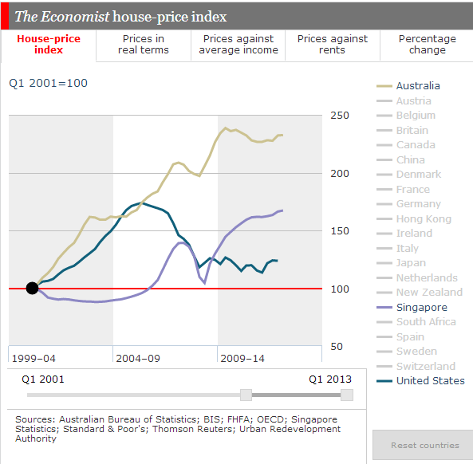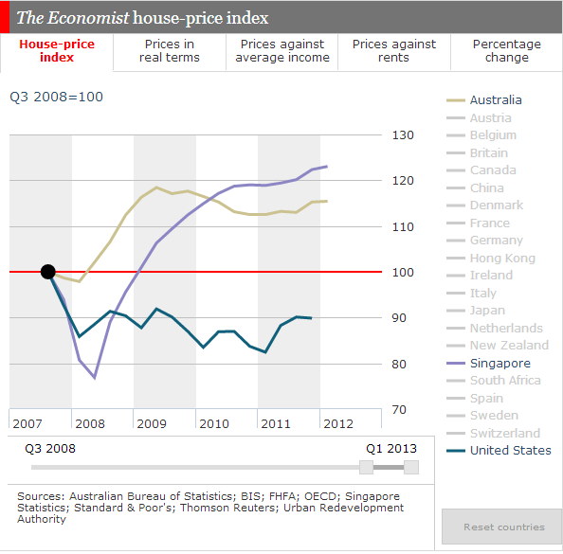

Source: The Economist, <http://www.economist.com/blogs/dailychart/2011/11/global-house-prices>

In the wake of the recent global financial crisis, there is an emerging policy debate concerning how to reduce the frequency and severity (magnitude) of these large swings of housing cycles. Policymakers need tools to track the deviation from “intrinsic” values, and to dampen the potential large swings of these housing markets cycles.

One linkage between the housing markets and the financial system is through house purchase financing (mortgage lenders make loans to homeowners against the house as collateral). Thanks to the innovation of financial products, millions of mortgage loans were packaged by Wall Street firms into mortgage-backed securities (MBS). The AIG Financial Products division and the monoline bond insurers played a key role in providing insurance against these mortgage securities.

Market values of the collaterals are subject to considerable volatility. Traditionally, mortgage lenders used the loan-to-value (LTV) ratio as a metric to provide guidelines for origination of individual mortgage loans, where the value in the “LTV” represents appraisal values, which are predominantly based on comparable sales at the time of mortgage loan origination. Zoeller (2008) discusses issues with the predominant appraisal approaches. Historically, from 1947-1996, the appraisal industry and the mortgage lending industry used multiple valuation methodologies including the cost approach. Since 1997, as the market comparable sales approach gained preeminence, the cost approach slipped out of favor and is no longer required for mortgages underwritten by Fannie Mae. With the recent housing market boom and bust, the comparable sales appraisal method proved to be pro-cyclical (i.e., cycle amplifying) and created major distortions from long-term intrinsic values. Essentially, the housing appraisals in the U.S. have been following the swings of the market values.

The U.S. housing market values are observed to be too volatile, rendering the LTV unreliable. Figure 2 shows the Case-Shiller index for U.S. national housing market as well as for Las Vegas. For an average house in the U.S., 80% loan-to-value in June 2006 became 112% loan-to-value in June 2010. For an average house in Las Vegas, 80% loan-to-value in June 2006 became 184% loan-to-value in June 2010.

**Figure 2: The Case-Shiller Indices for the U.S. and Las Vegas**

Judging by the volatility of historical housing market prices, academics and regulators realized that capital rules relying solely on market values cannot achieve counter-cyclical effects. During times of economic boom, it is politically difficult for policymakers to slam the brakes. What is needed is other metrics that are more indicative of the intrinsic value (and thus the long-term market values). A proposal under discussion among academics and policymakers is to use counter-cyclical loan-to-value, where the value is based on intrinsic values other than market prices.

Actuarial valuation is a time-honored professional practice, which is mostly based on estimates of costs and projections of long-term trends of economic and demographic trends. There is a philosophical debate between market values and actuarial values (see Appendix A). In this paper, we derive actuarial housing values based on a controlled rate of price change that reflects the fundamentals of housing markets and are less volatile than the market prices. The actuarial values can serve as a candidate for the “value” in calculating counter-cyclical loan-to-value at the portfolio level.

# Section 2. Methodology for Deriving Actuarial Housing Values

Our goal is to construct actuarial housing values that reflect the fundamentals and exhibit less volatility than market values. Toward that goal, we employ a control mechanism on the metro level housing price index so that it doesn’t boom too high above or crash too low below the fundamentals. The units in this control mechanism are the adjusted quarterly price change rates. We set a cap and a floor for the quarterly price change rate, and then adjust it with a drift term that incorporates the social and economic effects that affect the supply and demand for housing.

Notations:

Let $HPI(t)$ represent the housing price index at time *t*. In this paper we use $HPI(t)$ to represent the Case-Shiller indices for 20 metropolitan areas at quarterly frequencies.

The Quarterly Change (“QC”) at time *t* is defined by:

$$QC\left(t\right)=\frac{HPI(t)}{HPI(t-1)}-1$$

We use a ten-year moving window of housing prices for the past 40 quarters:

$\vec{QC(t)}=\left\{\begin{matrix}QC\left(t-j\right), & where & j=0,1,…,39\end{matrix}\right\}$.

We define $Cap(t)$ and $Floor(t)$ by the following formulae:

$Cap\left(t\right)=E\left[\vec{QC(t)}\right]+σ\left[\vec{QC(t)}\right]-drift$,

$Floor\left(t\right)=E\left[\vec{QC(t)}\right]-σ\left[\vec{QC(t)}\right]-drift$,

where the “drift” term is to be calibrated for the specific metropolitan area.

We compute controlled quarterly changes, $\hat{QC}(t)$, by imposing the updated *Cap* and *Floor* to the Quarterly Change in the Housing Price Index at time *t*.

$$\hat{QC}(t)=max\left\{Floor\left(t\right), \min\left(QC\left(t\right), Cap\left(t\right)\right)\right\}$$

We derive actuarial housing values by applying the controlled quarterly changes consecutively:

$AHV\left(t\right)=AHV(t-1)∙ \hat{QC}(t)$.

The actuarial housing values are derived from the inclusion of factors specific to the metro area being measured. The key to the actuarial method is the drift term, which is calibrated to reflect the *combined effects* of economic and demographic factors impacting the supply and demand of housing units in a metropolitan area. In the following sections, we examine some of these factors.

# Section 3. Data Used in the Calibration of Actuarial Values

Our goal is to analyze housing price data by metropolitan area and price range buckets. Below is a summary of the types and sources of data used for the calibration of the actuarial housing values. Some of the data sources are obtained from third-party data vendors.

|  |  |
| --- | --- |
| **Data** | **Data Source** |
| Case-Shiller Index | S&P |
| Housing Market Inventory Supply | Zillow |
| Foreclosure Home % in Transaction | Zillow |
| Newly Applied Building Permit | Census Bureau & Texas A&M University |
| Housing Inventory | Zillow |
| Construction Cost | Marshall & Swift/Boeckh |
| Demographic Information | U.S. Census Bureau |
| Households with Age Information | U.S. Department of Housing and Urban Development |
| Household Income at Zip Level | Internal Revenue Service |
| U.S. Household Formation | U.S. Census Bureau |
| International Sale in Housing Market | National Association of Realtors |
| Mortgage Loan Standard | Ellie Mae Origination Insight Report |
| House Price at Zip Level | Zillow |

# Section 4. Factors Impacting the Supply of Housing Units

First, we study important factors driving the housing market from the supply side.

Figure 3 shows that only around 10% of the houses listed monthly in the market are sold and this ratio has remained steady in the past five years. Inventory Supply is the total number on listings at the end of a month divided by the number of homes sold in that month. Data source: Zillow.

****Figure 3: U.S. Housing Market Inventory Supply****

We make a distinction between two types of housing units available for sale: (i) willing to sell and (ii) forced to sell.

1. Some homeowners have the flexibility of withdrawing from listing if a house is not sold within a reasonable time window (such as 1-2 months). The house owner may choose to re-list again at a later date when the housing market condition changes. We shall categorize this type of houses as “willing to sell”.
2. In contrast to the class of “willing to sell”, we observed that some houses would have a price reduction after a period of being listed without finding a buyer at or near the asking price. We shall categorize this type of house as “forced to sell”.

We further divide the “forced to sell” houses into four sub-classes: foreclosure, newly built, migration and death.

## 4.1 Foreclosure houses

A foreclosed house is one in which the owner is unable or unwilling to make his or her mortgage loan payments and the bank repossesses the house. A bank usually sells a foreclosed home through an auction process.

From Figure 4 we can see clearly that before the housing bubble, the foreclosure houses percentage of all U.S. house transactions is around 2%. This ratio jumped to 20% in 2009 and remained high after that. Since late 2007, the abnormally high foreclosure rate had a material impact on the housing prices, which caused a departure from long-term “equilibrium” housing values.

Figure 4: Monthly Foreclosure Homes as % of Transactions

*Data source: Zillow.

Our analysis reveals that when foreclosure home % increases to a very high level, since late 2008, this jump explains most of the price drops in various zip codes of a metro area. Figures 5 and 6 depict this relationship for Los Angeles and Phoenix, respectively.

Figure 5: Los Angeles 2008-2010 House Price Change vs. Foreclosure Home%

*Foreclosure home %: The average percentage of home sales between 01/2008 and 01/2010 where the home was foreclosed upon within the previous 12 months. Each dot in the graph above represents a zip code area. Data Source: Zillow.

Figure 6: Phoenix 2008-2010 House Price Change vs. Foreclosure Home%

## 4.2 Newly built houses

Generally speaking, newly built houses are under more pressure to sell in a short time than owner-occupied homes. Builders of new homes normally have liquidity constraints and incur carry-costs of serving their bank loans. However, data for newly built houses are not readily available. In this paper, we use the number of building permit applications as a proxy indicator of newly built homes.

Figure 7: Single Family Building Permit Applications

*Data source: Texas A&M University. <http://recenter.tamu.edu/data/bp/>

2002-2006: A Glut of Newly Built houses

From Figure 7 we observe that the during the time period of 2002-2006, there was a spike in building permit applications. The house permits applications in Phoenix during that time period were more than double that of the time period 1997-2001. Assuming there is a 2 to 4 year lag between building permit applications and newly built houses, and then it is reasonable to expect excess supply of new houses between 2007 and 2010.

2008-2012: Scarcity of Newly Built houses

It can be said that the strong housing market recovery in 2012 and 2013 is mainly due to the reduced inventory of houses. Other factors didn’t change significantly from 2011 to 2012, such as mortgage rates, foreclosure rates and the household income distribution.

The cumulative effect of fewer newly built houses from 2008 to 2012 eventually led to a low inventory of housing supply, coupled with years of delayed house purchases by newly formed families, resulted in a shift of the balance in the housing supply-demand equation.

Figure 8 is a plot of Phoenix’s one-year house price percentage change and the housing inventory ratio. A significantly negative relationship is observed between these two ratios.

Figure 8: Phoenix 2012-2013 Price Change vs. Inventory Ratio

* Each dot in the graph above represents a zip code area. Data source: Zillow.

Figure 9 shows the relationship between housing prices and construction costs for Las Vegas.

We find that the number of building permit applications is inversely correlated to the ratio of housing market price to construction cost. The housing price index dropped below the construction cost index after the burst of the housing bubble, which led to the recently low supply of newly built houses.

Figure 9: Las Vegas Historical House Price Index vs. Construction Cost Index

*Data Source: Case-Shiller Index and construction costs are from Marshall & Swift/Boeckh (MSB).

## 4.3 Migration (outflow)

The effects of demographic trends on the housing prices are well documented in academic literature (see Belsky, 2009; Myers et al, 2002).

In most cases, when people move to another city, they need to sell their original house quickly so that they can get cash for relocation and eliminate the carry cost of the empty house.

Detroit is the prime example of outflow migration. From 2000 to 2008, among our eight targeted metropolitan areas, Detroit is the only one which experienced a population decrease, and most of this decrease is due to the highly negative net migration. With its highly negative net migration, Detroit is also the only metropolitan area which had a nominal house price drop compared to 1998 among our eight targeted metro areas.

**Table 1: Population and Migration Change from 2000-2008**

|  |  |  |  |  |  |  |
| --- | --- | --- | --- | --- | --- | --- |
|  | Detroit | Las Vegas | Los Angeles | Phoenix | Tampa | Washington DC |
| 2000 Population | 4,452,558 | 1,375,535 | 12,365,624 | 3,251,887 | 2,396,011 | 4,796,065 |
| 2000-2008 Net Migration | -237,573 | 380,112 | -420,191 | 717,353 | 328,419 | 137,771 |
| 2000-2008 Population Change | -27,448 | 490,211 | 507,184 | 1,030,012 | 337,750 | 562,065 |
| 2000-2008 Population Change % | -0.60% | 35.60% | 4.10% | 31.70% | 14.10% | 11.70% |

Data Source: U.S. Census Bureau

## 4.4 Death

Age distribution also has an effect on housing supply. Tampa has a significantly higher percentage of older people which leads to a higher rate of death. Table 2 shows the the population and death statistics for eight metropolitan areas.

Table 2: Demographics and Death

|  |  |  |  |  |
| --- | --- | --- | --- | --- |
| Year 2000 | Total Households* | Age 62+ Households | Age 62+ % | Deaths** |
| Tampa | 1,009,284 | 337,379 | 33.4% | 28,577 |
| Chicago | 2,971,619 | 676,459 | 22.8% | 60,119 |
| Detroit | 1,695,304 | 419,494 | 24.7% | 39,407 |
| Houston | 1,462,676 | 239,397 | 16.4% | 28,319 |
| Las Vegas | 588,350 | 143,105 | 24.3% | 10,320 |
| Los Angeles | 3,133,781 | 655,301 | 20.9% | 59,352 |
| Phoenix | 1,194,271 | 288,563 | 24.2% | 24,272 |
| Washington | 1,848,021 | 340,126 | 18.4% | 29,838 |

*Households with age information is from HUD (U.S. Department of Housing and Urban Development)

**Death data is from U.S. Census Bureau

In Tampa, the houses for sale from death are roughly equal to the number of newly built houses. Below is the number of single family building permit applications in Tampa from 1996 to 2000.

|  |  |
| --- | --- |
| Single Family Building Permit Applications in Tampa | |
| 1996 | 10,006 |
| 1997 | 10,745 |
| 1998 | 11,573 |
| 1999 | 13,309 |
| 2000 | 13,293 |

If we simply assume two deaths will empty one house, the number of houses for sale due to death in Tampa for year 2000 is 14,288. The five year average number of applications for single family building permits is only 11,785.

To sum up this section, the supply of the housing market in the U.S. is composed of two different groups: willing to sell and forced to sell. Historically, the number of willing to sell houses is much higher than that of forced to sell houses. The forced to sell houses are composed of foreclosure houses, newly built houses, migration outflow houses, and houses emptied by death. The latter two factors are more fundamental and are changing relatively slowly from year to year. However, those two factors are quite different from region to region, such as Detroit (high migration outflow) and Tampa (high death rate), which determine the long term trend of the housing market. The former two factors are more affected by market conditions and could fluctuate rapidly in a relatively short period. For example, the number of foreclosure houses increased dramatically after housing bubble, an effect that dominated the housing price changes between 2008 and 2010. The recent housing market boom is in part due to the low inventory supply, which is because of the extremely low volume of newly built houses since 2008.

# Section 5. Factors Impacting the Demand for Housing Units

The following factors determine the housing market demand curve.

## 5.1 Household income distribution

Traditionally, housing economists use the ratio of median house price to median household income as the indicator for measuring housing affordability in their research. Our research indicates that such a ratio may not be the best indicator. Using a mortgage payment model, we have found that a higher percentile (e.g. 65%) of the income distribution is better metric than the median (50%) to match with transacted house prices.

In our mortgage payment model, we assume that the buyer pays a 20% down payment and takes 30-year mortgage for the remaining value of the house. We compared data for each zip code-level historical median traded house price with household income distribution within the same zip code. By using the historical mortgage rates, we match the median traded house price to a percentile of the household income distribution. By doing this calculation for all zip codes within one metro area, a house price matching income percentile distribution can be formed.

Figure 10 shows Chicago’s implied income percentile distribution.

Figure 10: Chicago 2008 House Price Implied Income Percentile

*Data source: house price is from Zillow. Household income is from Internal Revenue Service (IRS).

We calculated this income percentile distribution for all eight metro areas and only Detroit has an implied income percentile distribution with a median lower than 0.5. Some metro areas’ distribution medians are even higher than 0.7 or 0.8.

A possible explanation for this result is that people usually buy their houses between age 30 and 50, which is at the peak of their lifetime income curve. Therefore, if we compare their income to the total income distribution, the implied income percentile is usually higher than 0.5.

## 5.2 The Effect of Mortgage Rates on Affordable Prices

Changes in the mortgage rates have a parallel shift effect on demand curve of household income.

Based on the monthly cash flow formula, the affordable house price would be

$$Price=\frac{12M}{i}∙\left[1-\frac{1}{{\left(1+\frac{i}{12}\right)}^{12N}}\right]$$

Where:

1. $i$ is the annual mortgage rate,
2. $M$ is the monthly payment,
3. $N$ is the number of years of the mortgage.

Below is a table showing how the amount of affordable price is impacted by changes in the (30-year fixed) mortgage rate.

|  |  |  |  |
| --- | --- | --- | --- |
| $$i$$ | Price | $$i$$ | Price |
| 3.0% | 237,000 | 5.5% | 176,000 |
| 3.5% | 223,000 | 6.0% | 167,000 |
| 4.0% | 209,000 | 6.5% | 158,000 |
| 4.5% | 197,000 | 7.0% | 150,000 |
| 5.0% | 186,000 | 7.5% | 143,000 |

From the table above, we can observe that mortgage rate has a significant effect on the affordable price. An increase in the mortgage rate from 3.0% to 4.0% results in an almost 12% decrease (from 237,000 to 209,000) in the affordable price.

A caveat of this analysis is that homeowners incur other associated costs of homeownership, including property taxes, utilities, maintenance and homeowner’s insurance.

## 5.3 Age distribution

After the financial crisis, a shortfall in household formation is observed during 2008 to 2010. Figure 11 shows the recent ten years of available U.S. household formation data.

Figure 11: U.S. Household Formation

Data source: Census Bureau

The temporary delay in household formation is partially due to a so called “doubling up”, where recent college graduates stay in their parents’ houses waiting for a more stable job before buying their own first homes. When the housing markets recover, we expect that those who were waiting may come into the housing markets, which may increase the demand of housing market. Since young adults are more likely to be the source of the household formation, it is necessary to account for the age distributions in different metropolitan areas, especially for age group 18 to 35.

Some research papers have already proven that different age groups have varying effects on housing market. Lindh and Malmberg (2008) find that large populations of young adults are associated with higher rates of residential construction in Sweden. The effect of age group 15-29 on housing demand is more than twice of that effect of age group 30-49 and around five times that of age group 50-64.

## 5.4 International Sales

It is observed that more and more international buyers are entering the U.S. housing market, especially concentrated in three states: Florida, California, and Texas. Cities like Miami, Los Angeles, San Francisco, Dallas, and Houston experienced a significant international migration in the past decade. This continuing trend in net international migration resulted in a long-term boom in the local housing markets.

For example, Los Angeles experienced a continuous and significant international migration inflow since 2000. This extra international capital drives the local housing prices to an unreasonably high level. Figure 12 shows the housing price implied income percentiles before and after the housing bubble.

Figure 12: Los Angeles House Price Implied Income Percentile

**Left: Year 2001; Right: Year 2008**

Data Source: National Association of Realtors

# Section 6. Housing Market Dynamics

Traditional housing market analysis usually relies on regression techniques, which we consider to be inappropriate for housing markets. As we summarized at the end of the housing supply section of this paper, the housing market is a dynamic market, for which static analysis cannot capture the variation in price, especially in a volatile market.

Figure 13 is the graph of relationship between housing price change and foreclosure rate in the Los Angeles metro area. We can see that the foreclosure rate is a highly significant factor in explaining the housing price change between 2008 and 2010. However, this strong relationship soon disappeared in 2011.

Figure 13: Los Angeles House Price Change vs. Foreclosure Home%

Left: For the Years 2008-2010; Right: For the Years 2010-2011

For a given housing market, one factor could dominate the influence on housing price change during a specific time period. However, when market dynamics change, this dominating influence rapidly weakens or even disappears. Figure 14 shows the different dynamics of the housing market supply of Los Angeles and Phoenix before, right after, and further after housing bubble. As we can see, different factors in the metropolitan areas in different years have varying weights. Basically, demographic and economic conditions determine the fundamentals of a local housing market. Temporary high foreclosure rates and low inventory of newly built houses can be called market responses to unfair housing price levels and revert the price level back to its mean. Calibration of the drift term in the actuarial formulae requires an analysis of the dynamics of a given housing market.

Figure 14: Dynamics of Housing Market Supply

**Other Relative Price Indicators**

Researchers of real estate markets often resort to inferential analysis of housing markets (see Black et al, 2006; Edelstein and Tsang, 2007; Wheaton and Nechayev, 2008). They use analysis of house price to household income, house price to rents, vacancies, absorption/time on the market, prices, and construction starts to estimate normal vacancy rates and time on the market inventory. We considered these relative factors in understanding the dynamics of the housing markets.

Instead of the regression method, we propose the actuarial valuation presented at the beginning of this paper. Actuarial value is a housing price benchmark based on a controlled rate of price change, which is calibrated based on the dynamics of the metro specific housing markets.

In the next section we present the results of the actuarial housing value.

# Section 7. Results of Actuarial Housing Values

We apply the actuarial approach to housing price data at the metropolitan level. Figure 15 presents the results for Washington DC, Detroit, Los Angeles, and Phoenix.

Figure 15: Case-Shiller Housing price Indices vs. Actuarial Value

We calculated the actuarial value for the following metro areas: Chicago, Detroit, Houston, Las Vegas, Los Angeles, Phoenix, Tampa, and Washington DC. By using the annual trade volume as the weights, we derived the U.S. nationwide housing index.

We construct the U.S. nationwide actuarial housing value using weighted average of actuarial values for various metro areas, where the weights are determined by the annual transaction volume. In Figure 16 we compare the re-constructed (or weighted) Case Shiller index with the actuarial value for the U.S. national housing market.

Figure 16: U.S. Reconstructed Housing Case-Shiller vs. Actuarial Value

# Section 8. Potential Applications of the Actuarial Housing Value

Actuarial housing values can help actuaries to offer valuable professional services to the appraisal industry and the lenders. Knowing the relative relationship of actuarial housing values and market values can help regulators to effectively measure and manage systemic risks for the housing market, and the impacts of these risks on other sectors of the economy. Indeed, if the differences between the actuarial housing value and market values can be used as an input to the Gaussian copula model (see Li, 2000; Salmon, 2009) for credit default swaps, the correlation among mortgage-backed securities would have been much higher. Actuarial housing values can enable lenders to monitor the aggregate departures of actuarial values and market values, similar to the way that insurers track their aggregate catastrophe risk exposures. Actuarial housing values can also help actuaries to perform pricing and reserving functions for mortgage insurance. The actuarial housing value can even serve as a basis for designing reverse-mortgage products.

# Section 9. Areas of Future Research

As one promising area of future research, we can derive a distribution of actuarial housing values by housing price buckets. Figure 17 shows the house price changes from 12/1999 to 12/2012 for different price percentiles of several metro areas. From Figure 18 we observe higher price changes from 1999 to 2012 for houses at higher price ranks of each metro area. The different performances across different housing price buckets can further demonstrate the power of an actuarial approach.

Figure 17: Price Changes for Different House Price Ranks from 1999 to 2012

*Data Source: Zillow.

As another area of future research, we plan to adapt the actuarial valuation method presented in this paper to China’s housing markets, incorporating the special characteristics of China’s housing markets (as discussed in Appendix B).

# References

Adeyele J.S. and O.J. Adelakun (2010) Controversy between Financial Economics and Traditional Actuarial Approach to Pension Funding, Journal of Emerging Trends in Economics and Management Sciences 1(1): 1-5, 2010.

Belsky, E. S. “Demographics, markets, and the future of housing demand,” Journal of Housing Research, 18:2, 2009, 95-119.

Black, A., P. Fraser, and M. Hoesli, “House prices, fundamentals, and bubbles,” Journal of Business Finance & Accounting, 33:9/10, 2006, 1535-1555.

Day, T (2004) Financial Economics and Actuarial Practice. Publication of the Society of Actuaries.

Edelstein, R. H. and D. Tsang, “Dynamic Residential Housing Cycles Analysis,” Journal of Real Estate Finance and Economics, 35:3, 2007, 295-313.

Isaac, W. (2010) <http://www.williamisaac.com/published-works/mark-to-market-revisited-a-picture-is-worth-a-thousand-words/>

Li, D. X. (2000). "On Default Correlation: A Copula Function Approach". Journal of Fixed Income 9 (4): 43–54.

Lindh, T., and B. Malmberg, 2008, “Demography and Housing Demand—What Can We Learn from Residential Construction Data?”, Journal of Population Economics, Vol 21.

Myers, D., J. Pitkin, and J. Park, “Estimation of Housing Needs Amid Population Growth and Change,” Housing Policy Debate, v. 13, no. 3, 2002, 567-96.

Quigley, J. M., “Real estate prices and economic cycles, International Real Estate Review, 2:1, 1999, 1-20.

Salmon, F. (March 2009). "Recipe for Disaster: The Formula That Killed Wall Street". Wired Magazine 17 (3).

Spencer. G.(2013), Reserve Bank of New Zealand’s perspective on housing, Bank for International Settlements, <http://www.bis.org/review/r130409f.pdf>

Wheaton, W.C. and G. Nechayev, “The 1998-2005 housing ‘bubble’ and the current ‘correction’: what’s different this time?” Journal of Real Estate Research, 2008, 30:1, 1-26.

Zoeller, M. J., “What about residential appraisals?” RMA Journal, 91:3, 2008, 32-37.

# Appendix A. Market Value versus Actuarial Value

Mark-to-market accounting played a major role in the recent financial crisis – the volatilities of housing market values are amplified through the mark-to-market accounting of mortgage-backed securities and their CDOs.

In the boom years before the global financial crisis, market values received elevated importance, and were championed by financial economists. In contrast, actuarial values seemed to have lost favor and importance.

Adeyele and Adelakun (2010) give detailed discussions of the tensions between actuarial value and market value.

“The debate between financial economics and traditional actuarial science has continued to attract the attentions of the academics and practitioners from various disciplines around the world. A survey of the literature does not produce much consensus between the two sides of the debate (Day, 2004). A basic difference identified between traditional actuarial thinking and the philosophical framework of financial economics is encapsulated in the difference between value and price. Actuaries largely seek to place value on cash flow stream, whereas financial economists believe market should do that for them. In the view of financial economists, value is a subjective concept, whereas price is objective. However, a problem with this is that price, if it exist in a market where there is buying and selling, is, in fact, determined by the players on the margin who are willing to buy and sell at marginal price. There remains the fundamental problem that different players should hold different ideas of the intrinsic value of an investment, because they are holding the asset for different reasons.”

“One of the consequences of the difference in philosophy between value and price is the fact that actuaries are often concerned with control systems and with managing risk in the long run. Actuaries have often been concerned with those types of control issues. Pension funding presents a similar type of problem. However, the market approach of the financial economists crystallizes a view of the future into a snapshot view, through the use of market or fair value of asset and liabilities.”

William Isaac argued that mark-to-market accounting made the recent financial crisis unnecessarily more severe than it could have been if a more cost-based valuation were used. To make his points clear, William Isaac used two charts to illustrate the impact of mark to market accounting on just one portfolio of mortgage backed securities held by a large U.S. bank. The materials below are taken from William Isaac (2012):

“The chart (Exhibit I) showed that as of December 31, 2008, the bank held a pool of MBS totaling $3.65 billion. The bank expected a maximum of $100 million of losses on the portfolio but had enough extra collateral to cover those losses so no net losses were expected. Yet, mark to market accounting required the bank to write off over $900 million of the portfolio.

As of March 31, 2011 the bank updated the chart showing the performance of this same portfolio (Exhibit II). The portfolio declined to $2.1 billion due to prepayments and normal amortizations. The bank now expects total net losses of $28 million. The mark to market charge on the portfolio has been reduced from over $900 million at the end of 2008 to just $44 million, even though nothing has really changed except market perceptions of value! It was very bad accounting during the Great Depression when President Roosevelt ordered it eliminated in favor of historical cost accounting, and it was very bad accounting during the crisis of 2008-2009 when it helped bring our nation’s financial system and economy to the brink of collapse.”

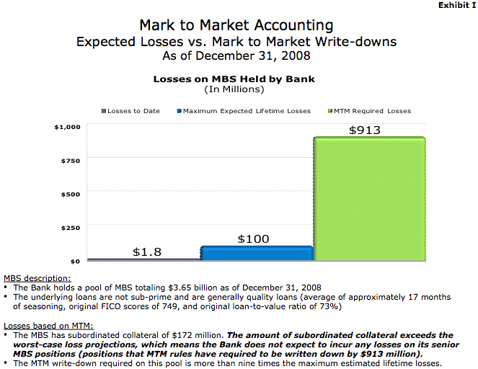

[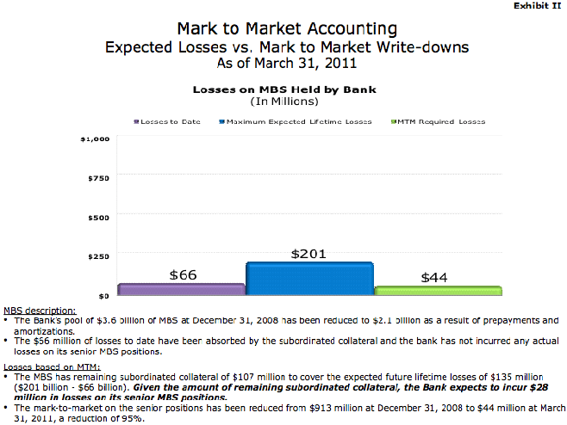](http://www.williamisaac.com/wp-content/uploads/2011/06/exhibit2c.gif)

We do not intend to enter the debate between the actuarial versus the financial economics approaches. Instead, we take a position that both approaches are needed to complement each other; it is by comparing the differences between the market values and the actuarial values that we derive useful metrics for navigating through the sea of uncertainty.

# Appendix B: China’s Housing Markets

## B1. Carry cost and maintenance fees

Compared to the U.S. housing market, China’s housing market has a much lower long term carry cost. This is mainly due to two reasons:

1. Most residences in China are apartments, which require minimal effort to maintain. The annual maintenance fee can be as low as zero for an empty apartment.
2. Currently, there is no property tax in China. The only long-term carry cost is the property management fee, which is usually lower than 0.1% of the apartment value.

Considering the high inflation rate in China, its housing market is one of the best-performing asset classes because of its low carry cost and expectations of future price appreciation.

## B2. Density of Population & Migration

China has four tiers (levels) of cities, which have quite different population densities and migration conditions.

The level one and two cities in China have very high population densities and are experiencing a continuous migration. For example, the New York metro area had the highest density of population in the U.S. in 2008, which were 2,826 people per square mile. For Shanghai, this number was more than 12,000.

Meanwhile, the level three and four cities in China have a comparatively lower population density. And for level three and four cities in middle and western China, the effect of migration from rural areas is offset by the trend of residents continuously moving out to level one and two cities. The limited demand and over-supply in some level three and four cities results in the phenomenon of “ghost cities”.

Below is the population table of the level one and three cities in China eastern and non-eastern area. Beijing, Shanghai, and Guangzhou are level one cities and others are all level three cities.

Table 3: China Level 1 & 3 Cities Population Change



Data Source: China National Statistics Bureau

Age Distribution: China currently has a significantly lower ratio in the age 65+ demographic. This ratio was 8.87% in 2010. For U.S. metro areas, most of these ratios are near 20%.

Table 4: China Demographic Condition

|  |  |  |  |  |  |  |  |
| --- | --- | --- | --- | --- | --- | --- | --- |
| Year 2010 (000) | Population | <15 Population | <15 % | 15-64 Population | 15-64 % | >= 65 Population | >=65 % |
|
| Mainland China | 1,339,725 | 222,460 | 17% | 998,433 | 75% | 118,832 | 9% |
| Zhejiang | 54,427 | 7,189 | 13% | 39,679 | 73% | 7,559 | 14% |
| Chongqing | 28,846 | 4,898 | 17% | 20,614 | 71% | 3,334 | 12% |
| Sichuan | 80,418 | 13,644 | 17% | 57,966 | 72% | 8,808 | 11% |
| Jiangshu | 78,660 | 10,230 | 13% | 59,862 | 76% | 8,568 | 11% |
| Liaoning | 43,746 | 4,997 | 11% | 34,240 | 78% | 4,509 | 10% |
| Anhui | 59,501 | 10,699 | 18% | 42,745 | 72% | 6,057 | 10% |
| Shanghai | 23,019 | 1,986 | 9% | 18,704 | 81% | 2,330 | 10% |
| Shandong | 95,793 | 15,074 | 16% | 71,289 | 74% | 9,430 | 10% |
| Hunan | 65,684 | 11,574 | 18% | 47,686 | 73% | 6,424 | 10% |
| Guangxi | 46,027 | 9,991 | 22% | 31,782 | 69% | 4,253 | 9% |
| Hubei | 57,238 | 7,964 | 14% | 44,070 | 77% | 5,204 | 9% |
| Beijing | 19,612 | 1,687 | 9% | 16,216 | 83% | 1,709 | 9% |

Data Source: China National Statistics Bureau

Table 5: U.S. Demographic Condition

|  |  |  |  |
| --- | --- | --- | --- |
| Y2000 | Total Households | Age 62+ Households | Age 62+ % |
| Tampa | 1,009,284 | 337,379 | 33.4% |
| Chicago | 2,971,619 | 676,459 | 22.8% |
| Detroit | 1,695,304 | 419,494 | 24.7% |
| Houston | 1,462,676 | 239,397 | 16.4% |
| Las Vegas | 588,350 | 143,105 | 24.3% |
| Los Angeles | 3,133,781 | 655,301 | 20.9% |
| Phoenix | 1,194,271 | 288,563 | 24.2% |
| Washington | 1,848,021 | 340,126 | 18.4% |

However, due to the One Child Policy applied in 1979, the old people % in China is projected to double before 2030. This ratio will even increase more in urban area since the One Child Policy was mainly executed in cities rather than the whole country.

## B3. Capital Inflows

When additional capital comes into housing market, the market price will be driven to a higher level than the reasonable price.

In China, due to the low carry cost and housing price increase expectations in level one and two cities, many wealthy people invest their fortune in real estate markets. The number of houses (apartments) is considered to be a sign of fortune in China nowadays. This phenomenon directly results in a high home vacancy rate. In U.S., the long term vacancy rate is below 2%. In China, some surveys like usage of electricity imply that the vacancy rate is even more than 20% in some major cities.