The Power of the Collective; The Death of the Collective

Robert L. Brown

Dept. of Statistics and Actuarial Science

University of Waterloo

Introduction

I taught actuarial science at the University of Waterloo for 39 years. Waterloo County has a strong Mennonite population. I often referred to this Mennonite community in my introductory lectures on insurance.

I believe that security through the insurance is built on a similar foundation to security in the Mennonite community; namely, collective risk sharing.

As an example: a Mennonite barn burns down taking with it 40 milking cows. How does the Mennonite community respond? Within a few days, neighboring farmers (let’s say 39) and their families gather to rebuild the barn. But each neighbor also brings one milking cow. By the end of the day, the Mennonite who had the barn fire is virtually whole. He has a new barn and 39 milking cows. The wider community has contributed one day’s work and one milking cow, a manageable ‘loss’.

Modern insurance is really just a formalized mechanism mirroring Mennonite risk sharing with an insurance company administering the process. This process depends on a collective view of risk. Hundreds of policyholders sign contracts that state that their collective cohort will make any policyholder, who has an unfortunate event, whole. It is not a big stretch to propose that 39/40 policyholders will pay the economic cost for the one policyholder who has an unfortunate loss. In that way, individuals can pay 1/40 of their expected loss (plus expenses) and know that they are now immune to economic risk.

Through the Law of Large Numbers, the insurer can do this without assuming very much risk itself. That is, if an insurer has hundreds of independent policyholders, the outcome for this total block of business is highly predictable. Thus, we have the magic whereby individuals can transfer risk, apparently to the insurer, without the insurer assuming that risk. Of course, what is really happening is that each policyholder is joining a large cohort of policyholders and attaching to the highly predictable outcome of the collective.

It is this use of the collective that makes insurance work. And it is a miraculous financial instrument. At least, that is what I (proudly) told my students.

But, modern reality is significantly different than the insurance nirvana outlined above. Today there is a strongly increased focus on individual equity that erodes the principles of collective risk sharing. This has been aided and abetted by the acumen of actuaries.

The paper will now discuss this philosophical transition one line of business at a time.

Life Insurance
Clearly the Law of Large Numbers applies to Life Insurance. With a portfolio of a large number of independent risks, life insurance expected claims are highly predictable. Premiums can be set with a high level of confidence.

Within this framework, however, underwriters and actuaries are striving to create a higher degree of individual equity. We have separate mortality tables by gender and by smoking habits. But it doesn’t stop there. We create further risk classes by digging more deeply into the applicant’s medical history, their financial history and their moral history with resultant risk and price categories. In some instances, we find the applicant uninsurable and deny them coverage. We do this to constrain the impact that adverse selection can have on the insurance process. Adverse selection exists because the insurer can never know as much about the risk profile of the applicant as the applicant does.

Despite this attempt to achieve full individual equity, whereby the insured pays exactly the expected value of his/her benefits, Life Insurance continues to benefit from the Law of Large Numbers and the benefit of the collective.

But how much longer will this be true? Private agencies are now selling DNA profiles to individuals. To date, these have not been widely used because they have been both very expensive and not very accurate. But, every year, they become less expensive and more accurate.

The Life Insurance industry has taken the position that so long as individuals do not have their DNA information, then the insurers will not demand such information. That is, so long as there is information symmetry (see the Society of Actuaries, 1999 and the American Academy of Actuaries, 2000), the insurer will ignore the applicant’s DNA profile.

But what happens when a growing percentage of the population does have this DNA information? Won’t the insurance industry have to respond?

How long will it be before a DNA analysis is a requirement of the application for insurance? And, then what happens to the collective principle of insurance?

Premiums for insurance must exceed the expected value of the benefits to cover expenses. Buying insurance is still a good idea if you can see that the utility value of insurance exceeds the utility value of the premium. But this requires that there be some significant variance or degree of ‘unknownness’ about the time of death. If the insurer and the applicant know within a very small range what the time of death will be (outside of accidental death) then why would anyone buy (or sell) insurance?

Is the basic life insurance mechanism in danger of extinction? [Note that arguments downplaying this concern can be found in Viswanathan et al, (2007)].

Health Insurance

This discussion starts with many of the same building blocks as for Life Insurance. Also much of the debate around asymmetrical information with respect to DNA applies to private Health Insurance (see MacMinn et al (2007)).

Once again, in private health insurance, the insurer would like to charge a premium that comes as close to individual equity as can be actuarially attained. But, in the U.S. (one of the few developed countries where Health Care Delivery is still a private sector system) the passage of the Patient Protection and Affordable Care Act of 2010 (ObamaCare) will make that more difficult. Under these new rules (to be phased in by 2014), while private insurance coverage is still the main foundation, several restrictions apply:

--if you get sick, you cannot have your coverage terminated by the insurer
--rate increases must be approved by the State
--80% of the premium must pay costs/benefits (i.e., only 20% of the premium can go for administrative/sales costs)
--the insurer can no longer deny coverage to adults because of pre-existing conditions
--consumers will have a web site “Exchange” available to them to help in finding less expensive and more appropriate coverage

Several results are expected from this legislation:
--some employers will drop their group health insurance and just let their employees find individual coverage
--people may go to their doctors earlier for assistance which would lower costs in the longer run
--with universal coverage, premiums overall might be lower
--however, given the compression of pricing by age (age band compression where younger people pay more for their coverage than its expected value so that older people can pay less), younger Americans might decide not to participate since their premiums will exceed the expected value of their benefits (even though there are penalties for such non-participation). This would result in higher average premiums.

But, regardless of the outcomes, the ObamaCare system is a return to a more “collective” approach to the delivery of private health insurance and is thus consistent with the philosophy of the “power of the collective”.

Further moves in this direction should be anticipated.

Property/Casualty Insurance

While this section relates almost entirely to automobile insurance, the principles discussed have much broader application (including private Health Insurance).

If one were to go back only 25 years, risk classification in automobile insurance was fairly rudimentary. Rates would vary depending on whether you were an urban versus a rural driver and whether your primary use of the car was for business or pleasure. Rates would also depend on your driving record (basically your claims in the past ‘n’ years) but ‘n’ tended to be five and forgiveness of claims, especially for mature drivers, was common. Rates would vary by age, but only up to age 25. Similarly, under age 25, rates would vary by gender. Finally, rates would vary by car code (its value and some other attributes), but the list virtually ended there.

The world has changed. The emphasis is now on ‘data mining’ and ‘predictive modeling’. What can we find out about the policyholder so as to achieve ever-higher levels of individual equity? Obviously, individual equity is good; every policyholder should pay his/her expected losses.

As one example, we have extended the Driving Record variable from five years to seven. Two or more moving vehicle violations (e.g., speeding tickets) are now considered equivalent to an accident. Forgiveness is now uncommon, although some companies now sell ‘forgiveness insurance’ for an extra premium. Rating territories can be as small as a postal or zip code (although some jurisdictions have restricted this because of the connection between neighborhoods and demographic variables, see Miller (2009)).

Other new rate classification variables have emerged. What is the policyholder’s credit rating (again, a politically sensitive classification variable-see Brockett and Golden (2007))? In the last ‘n’ years, how many times has this policyholder paid a late premium? How long has this policyholder lived at the same address? The possibilities seem unlimited.

Companies are now offering a discount if you attach a computer-monitoring device to your car. (This is called “pay-as-you-drive” insurance in the UK and Usage Based insurance in the U.S.). This device will tell the insurer how far you drive in a year. But it can also tell the insurer when you drive, at what speed, how often you apply heavy pressure to your brakes and even your driving destinations (GPS). Again, such methods are proving to be controversial in some jurisdictions. This program is currently completely voluntary, but it does show that these possibilities do exist. In fact, the U.S. National Highway Traffic Safety Administration wants to make event-data recorders mandatory for all cars (this is not motivated by risk classification reasons).

What has been the consumer response? Predictably, consumers have moved to higher deductibles (with the Driving Record penalty they are not going to report a small claim anyway). But even for claims in excess of these larger deductibles, policyholders agonize over making a claim. One claim means seven years of elevated premiums. Would our Mennonite friends report their barn fire if the result were a seven-year period of being shunned by the community? Is this truly the way that insurance was meant to operate? Aren’t some accidents just that…accidents? Correlations do not prove cause and effect, they are just correlations.

Is this emphasis on individual equity what our customers want? They buy insurance precisely to avoid anxiety and angst because of a claim. One buys insurance so that the result is security, not insecurity. I would further submit that consumers now view the insuring mechanism with anger and bitterness. Not what I want to tell my students.

Again, we see the push for individual equity overwhelming the advantages of the collective.

Life Annuities

With respect to Life Annuities, the insurance industry’s methods have resulted in a significant proportion of the population not being able to buy a life annuity at a fair market price.

It is a long-held axiom that if a person voluntarily wishes to buy a life annuity, he/she must be in very good health. Again, we invoke the principle of adverse selection: the applicant will always know more about his/her health than the insurer. Thus, we price assuming the applicant will use this extra knowledge to select against us. In life annuities, that means we price virtually all annuities as if the annuitant has five-star life expectancy.

Obviously, this results in a huge proportion of the population not being able to buy life annuities at a fair market price (see, for example, Brown, 2000). Mitchell et al (1999) show that the expected present value of annuity payouts per dollar of annuity premium averages between 80 and 85 cents for an individual chosen (at random) from the population, but between 90 and 94 cents for an individual chosen (at random) from the pool of individuals who purchase annuities. This value difference could be alleviated if there were more risk classification within annuity pricing.

This has a socially negative impact in that low-income workers really have no access to the wonderful risk minimization that life annuities provide. This is because low-income workers have measurably lower life expectancies than wealthy workers (Brown and McDaid, 2003) so that today’s annuities are not a fair deal for these poorer workers. Interestingly enough, for annuities, it would be advantageous for those in poorer health to be able to use DNA evidence to achieve higher annuity income.

What will happen if we continue on this course? I would expect increased pressure for more government involvement in providing retirement income security, either through a larger social security system (where there are progressive system design features that overcome the regressive nature of the payout phase) or through government-sponsored commingled annuity pools. Such pools are already being discussed by some states and provinces (see, for example, Matheson, 2009).

Pensions and Social Security

We have seen remarkable shifts in the past twenty years in providing retirement income security. Whereas the majority of workers used to participate in employer-sponsored Defined Benefit (DB) plans, there is a growing move to Defined Contribution (DC) and 401(k) plans. What is the impact?

DB plans have the benefit of collective sharing of risk as they involve a collection of workers (often numbering in the thousands). Thus, the mortality expectation becomes more highly predictable and manageable. Investment risk can also be shared across the collective and even across generations of workers. The fact that your retirement date was 2009 need not relegate you to massive reductions in your standard of living that many DC participants now face.

Being in a collective DB plan has other advantages. Size matters. The larger the size of the plan, the lower is the per-unit cost of investment management and administration. Investment management fees for large plans can be as low as 28 basis points (Ghilarducci, 2007). For individual account DC plans, they can easily be as high as 300 basis points (3%). In a world of gross rates of return of 5.5% and inflation of 2.5%, a management expense ratio (MER) of 3% means you are getting no increase in purchasing power from your assets whatsoever.

In an individual account DC plan, the worker also carries the investment and interest rate risk (which is a function of one’s year of retirement). Retiring in 2009 was not a good idea. Your assets (assuming the worker has not been buying deferred annuities) were most likely down 20 to 40% from a year previous.

The investment risk is illustrated in the graph that follows.

Figure 1

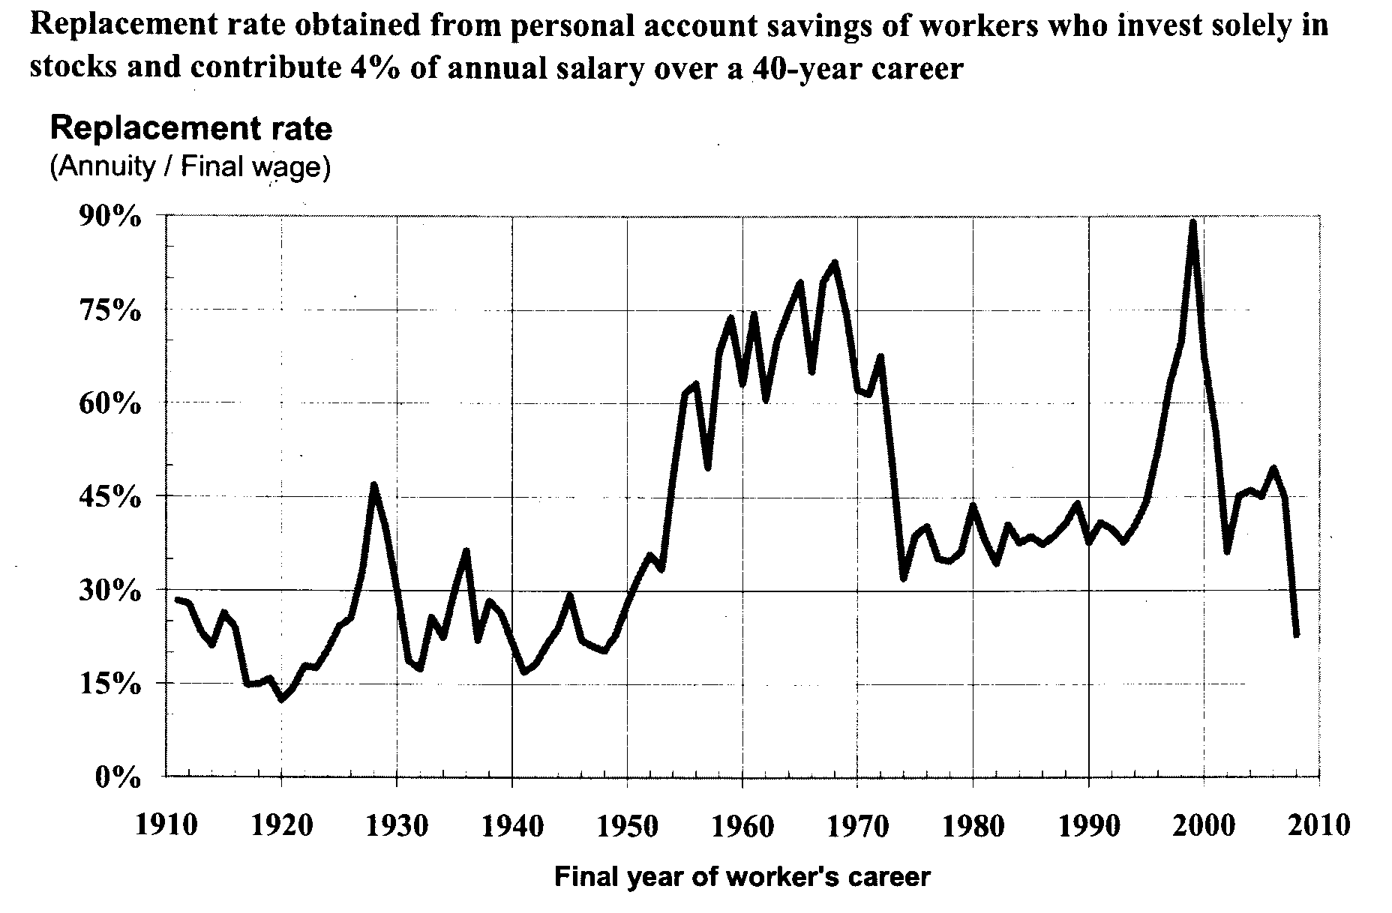
Source: Burtless, 2009 p 12

Clearly, the worker can decrease the portfolio risk by choosing less volatile investments such as government bonds. But that also decreases the Replacement Rates as seen in Figure 2.

Figure 2

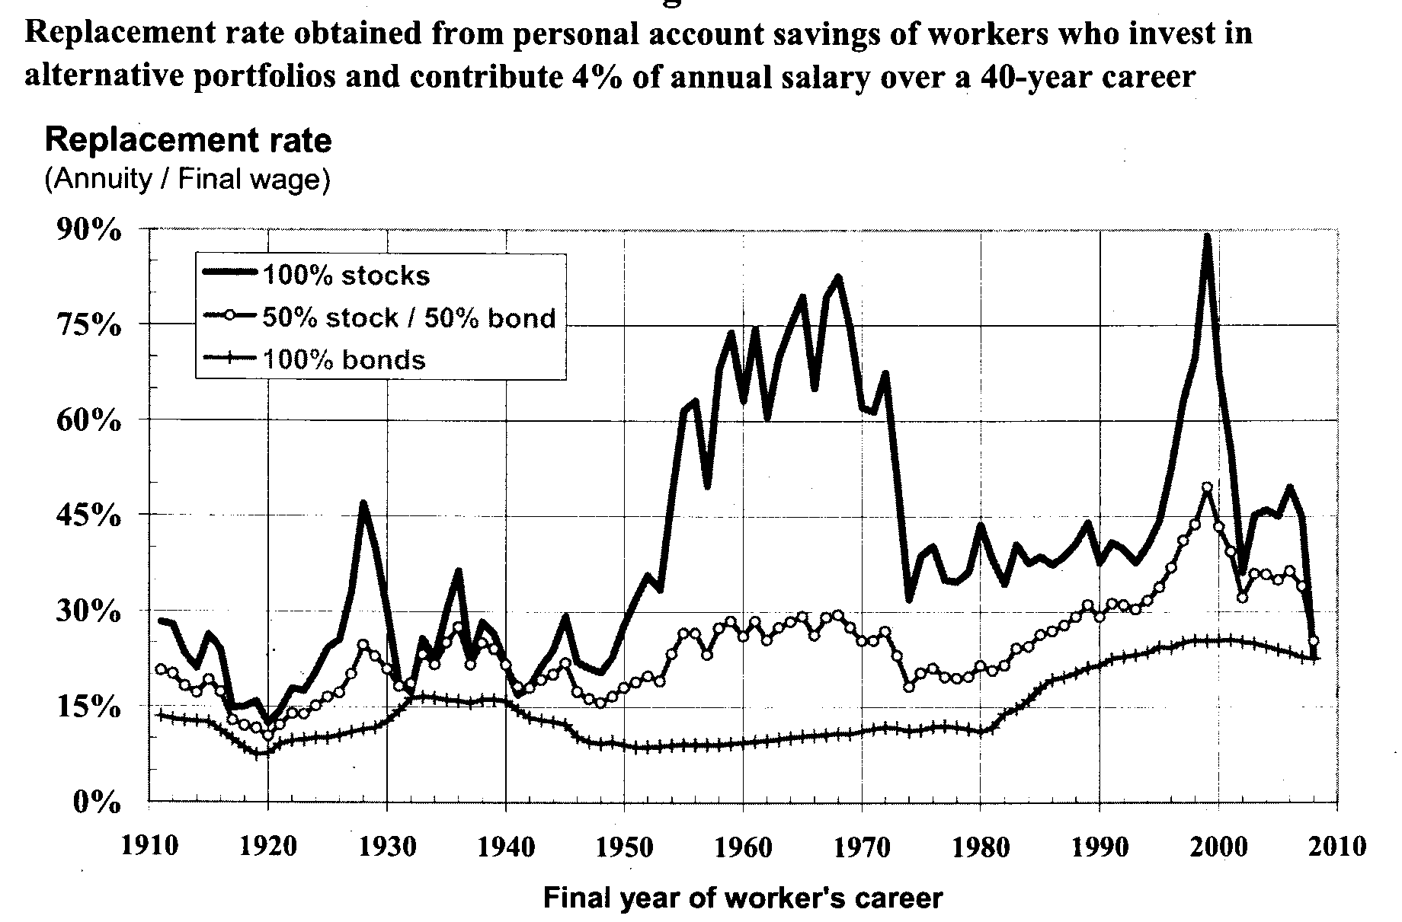

Source: Burtless, 2009, p 16

Further, if you voluntarily buy a retirement annuity, the insurer will assume five-star life expectancy and price the annuity accordingly (see the previous discussion). Again, the ultimate result may be pressure for more government intervention in providing retirement income security.

In summary, in individual account DC plans, the individual carries the risk. There is presently no way to share the risk at a market efficient price.

Moving to Social Security, the present systems in Canada and the United States are both partially funded DB systems. And both systems have progressive design features that overcome the regressivity of the payout phase (see Brown 1998).

At the turn of the century, President Bush, and others, proposed to move OASDI to an Individual Accounts system. This has been tried in many countries and one is hard pressed to find a success story (see, for example, Arenas de Mesa and Lago (2006), Gill et al. (2004) or Sinha (2002)). Think of the disaster that moving OASDI to Individual Accounts during the Bush years would have resulted in today.

This is just another example of the (unwise) push to have individual equity take priority over collective risk sharing.

Discussion and Conclusion

If one agrees with the sentiment of this paper, one would conclude that the insurance industry is moving in the wrong direction, aided and abetted by the acumen of actuaries. Why are we moving so vehemently in the direction of individual equity if it might destroy the inherent advantages of the broader collective?

The answer is ‘profit’. Buying and selling insurance is not compulsory. Insurers must find ways to conduct their business that optimizes both the desires of the consumer and the profitability of the insurance enterprise. This is not a criticism; it is simply a statement of fact. If an insurer does not make a profit, it is out of business.

What is the connection between the absolute need to create a profit and the drive to increased individual equity?

The insurance industry is highly competitive. Consumers look for low prices. Insurers look for profit margins. If I can refine my risk classification system so that the ‘best’ risks can buy my products at a lower price, then I can increase my market share with profitable business. If my competitor across the street does not refine its risk classification system, then my worst customers will move to their book of business (because their ‘average’ price will be lower) and their best customers will move to my book of business (because of my more-refined risk classification system). That seems laudable. Better customers pay lower prices and worse customers pay higher prices.

There is no reason to oppose this natural evolution. Certainly, one cannot state that it is ‘wrong’. However, as argued above, the ultimate outcome could be the demise of the collective and, therefore, the demise of the private insurance industry. If we could attain 100% accurate pricing for every individual, no-one would buy insurance. This is because there is a necessary expense in the insuring mechanism that can only make economic sense if there is variance in the economic outcome.

I would submit that very few insurance customers could articulate the connection between insurance and collective risk sharing but I think they have an instinct that the two are and must be connected. That is, they innately understand the power of the collective. The harder we work to attain pure individual equity in the insurance mechanism, the more we attack the fundamentals of collective risk sharing; the more we create an environment where the collective will die and, perhaps with it, the insurance industry.

Bibliography

American Academy of Actuaries (2000). Genetic Information and Medical Expense Insurance. Public Policy Monograph, June. Washington, DC.

Arenas de Mesa, A., C. Mesa Lago (2006). The structural pension reform in Chile: Effects, comparisons with other Latin American reforms, and lessons. Oxford University Press.

Brockett, P. L., and L. Golden (2007). Biological and psychobehavioral correlates of credit scores and automobile insurance losses: toward an explication of why credit scoring works. Journal of Risk and Insurance. Vol. 74 (1).

Brown, J. R. (2000). Differential Mortality and the Value of Individual Account Retirement Annuities. Working Paper 7560, National Bureau of Economic Research. http://www.nber.org/papers/w7560

Brown, R. L. (1998). Social Security: Regressive or Progressive? North American Actuarial Journal 2, No. 2 (April):1-33.

Brown, R. L. and J. McDaid (2003). Factors Affecting Retirement Mortality. North American Actuarial Journal. Vol. 7, No. 2, April, pp 24-33.

Burtless, G. (2009). Lessons of the Financial Crisis for the Design of National Pension Systems. CESIFO Working Paper No. 2735, July.

Ghilarducci, T. (2007) Vehicles for Collective Provision of Pension Services: Pension Plans for Small and Medium sized Enterprises, Research Project #12. The Ontario Expert Commission on Pensions.

Gill, I. S., T. G. Packard, and J. Yermo. (2004). Keeping the Promise of Social Security in Latin America. Palo Alto, California: Stanford University Press for the World Bank.

MacMinn, R. D., P. L. Brockett, and J. A. Raeburn (2007). Health Insurance, Genetic Testing and Adverse Selection. Annals of Actuarial Science. Vol. 2, Part II.

Matheson, S. J. (2009). Washington Voluntary Accounts: Report to the Legislature.
Washington State Department of Retirement Systems, January.

Miller, M. (2009). Disparate Impact and Unfairly Discriminatory Insurance Rates. Casualty Actuarial Society E-Forum, Winter.

Mitchell, O.S., J. M. Poterba, M. J. Warshawsky, and J. R. Brown (1999). New Evidence on the Money’s Worth of Individual Annuities. American Economic Review, Vol. 89, No. 5, pp 1299-1318.

Sinha, T. (2002). ‘Retrospective and Prospective Analysis of the Privatized Mandatory Pension System in Mexico’. Society of Actuaries Monograph.

Society of Actuaries (1999). North American Actuarial Journal. Vol. 3, No. 1, January. Genetic Technology and Underwriting: The 1998 Bowles Symposium.

