[Royal Institution: Science Lives Here](http://www.rigb.org/)

[About](http://www.rigb.org/about) → [News](http://www.rigb.org/about/news) → [Spring 2014](http://www.rigb.org/about/news/spring-2014) → [London Mathematics Masterclasses](http://www.rigb.org/about/news/spring-2014/london-mathematics-masterclasses) →

**Mathematics Masterclasses expand to inspire more students across the capital**

A new three year partnership with the Company of Actuaries Charitable Trust will double the reach of our Mathematics Masterclasses for upper secondary school students in the capital.

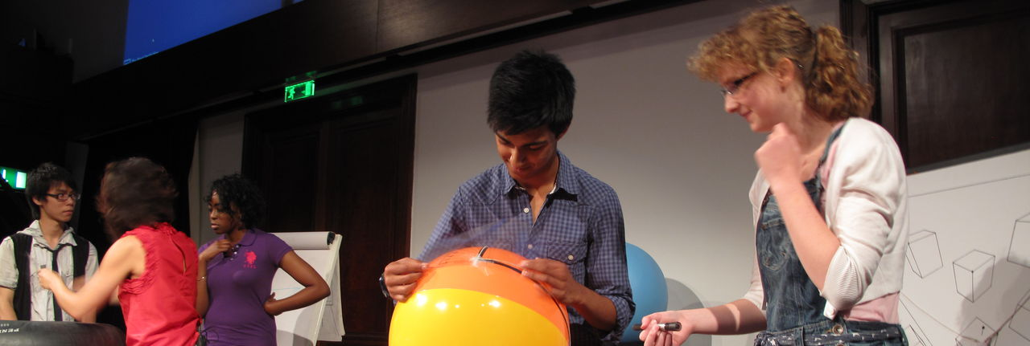

**News**

We are delighted to announce that the Company of Actuaries Charitable Trust (CACT), a new Ri supporter, will provide £54,000 of funding over the next three years to help double the reach of our [Mathematics Masterclasses](http://www.rigb.org/education/masterclasses/about) for upper secondary school students in London.

[Diane Crann](http://www.rigb.org/about/organisation/team/masterclasses/diane-crann), Ri Masterclass Programme Manager, said: “Our aim is to open the eyes of young people to the excitement, beauty and value of mathematics and to highlight the wide range of exciting careers this subject can lead to.

“Our London programme for upper secondary school students aged 15 to 18 years old already engages with 400 talented young people from across the capital each year. With the generous support of CACT we will double this number to 800 young people.

“Ri Mathematics Masterclasses currently take place at London Metropolitan University, Greenwich University and Imperial College throughout the year.

"This funding will allow us to run even more Masterclasses with these existing university partners, as well launch new Masterclasses series with Queen Mary University of London in east London and University College London.

She added: “The success of these hands-on sessions largely depends on the expertise and enthusiasm of our speakers and helpers who generously give up their spare time to share their love of maths with our students.

"We are also very pleased that members of the Worshipful Company of Actuaries will have the opportunity to volunteer with Ri Masterclasses and use their personal experiences and professional skills to help inspire the next generation of mathematicians.”

Michael Turner, Chairman of the Trustees of CACT, said: “The Company of Actuaries Charitable Trust is delighted to be involved with the Ri Mathematics Masterclasses which have inspired a number of actuaries to pursue mathematical careers. We very much hope that, by supporting more Mathematics Masterclasses for older children, we will fire enthusiasm in the next generation of actuaries.”

Ri Mathematics Masterclasses currently reach a total of 1,200 primary and secondary school students in London.

**About CACT**

The Company of Actuaries Charitable Trust (CACT) is the charitable arm of the Worshipful Company of Actuaries (WCA) which is one of the modern livery companies in the City of London. The Trust supports a number of aims, including those which advance mathematics education relevant to actuaries.

More information about CACT and the WCA can be found on the company’s website [www.actuariescompany.co.uk](http://www.actuariescompany.co.uk/)

**About Mathematics Masterclasses**

Ri Mathematics Masterclasses are a national network of hands-on and interactive extracurricular sessions led by top experts from academia and industry, which started in 1981. The unique programme, in which students attend a series of eight weekly sessions, goes beyond the school curriculum and brings maths to life in surprising topics such as art and sculpture, computer science, design, medicine and cryptography.

**Feedback**

"I feel very lucky to have been invited, the classes have extended my knowledge of the workings of maths and have helped build my confidence." *Year 11 Masterclass student*

[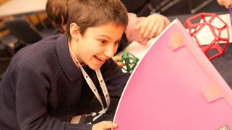](http://www.rigb.org/education/masterclasses/about)

[[](http://www.rigb.org/education/masterclasses/about)](Find out more About Masterclasses :      http://www.rigb.org/education/masterclasses/about)

[Find out more About Masterclasses :](Find out more About Masterclasses :      http://www.rigb.org/education/masterclasses/about)

[http://www.rigb.org/education/masterclasses/about](Find out more About Masterclasses :      http://www.rigb.org/education/masterclasses/about)