**ICA 2014 CONGRESS**

**WASHINGTON, APRIL 2014**

**ISSUES AROUND RETIREMENT AGE**

**A CIA TASK FORCE REPORT**

**Robert L. Brown, (Chair)**

**FCIA, FSA, ACAS, FIA (Hon)**

**a) Introduction**

The Canadian Institute of Actuaries (CIA) formed this Task Force to prepare background information to assist the CIA in taking a position on whether the “retirement age” should be increased. How should the issue be presented by the CIA? What are the consequences of raising the “retirement age”?

The first issue with which the Task Force grappled was how to define “retirement age”. What does it mean in a modern society? The working definition used by the Task Force was that “retirement” meant exiting the Labour Force as evidenced by employment Income no longer being the major source of income. This is often a long and random process; a transition rather than an event at a point in time.

**b) Canadian Shifting Demographics**

Canada’s post-war baby boom is now starting to retire and it will be fully retired by 2031. The labour force will then have to look to the baby bust cohorts for its supply and the ability to produce goods and services.

As can be seen in Figure 1, Canada had a more pronounced baby boom than the United States with a higher peak and a lower valley. That will mean that the Canadian Dependency Ratios will rise more rapidly than those of the United States as will be seen later.

**Figure 1 Total Fertility Rates: Canada and the United States**

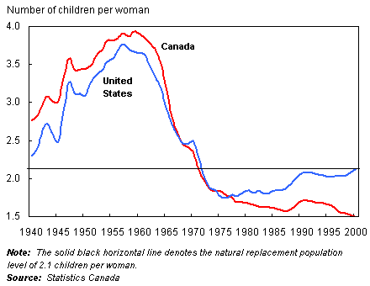

Figure 2 shows births and deaths in Canada from 1926 to the present and projected to 2056.

**Figure 2**

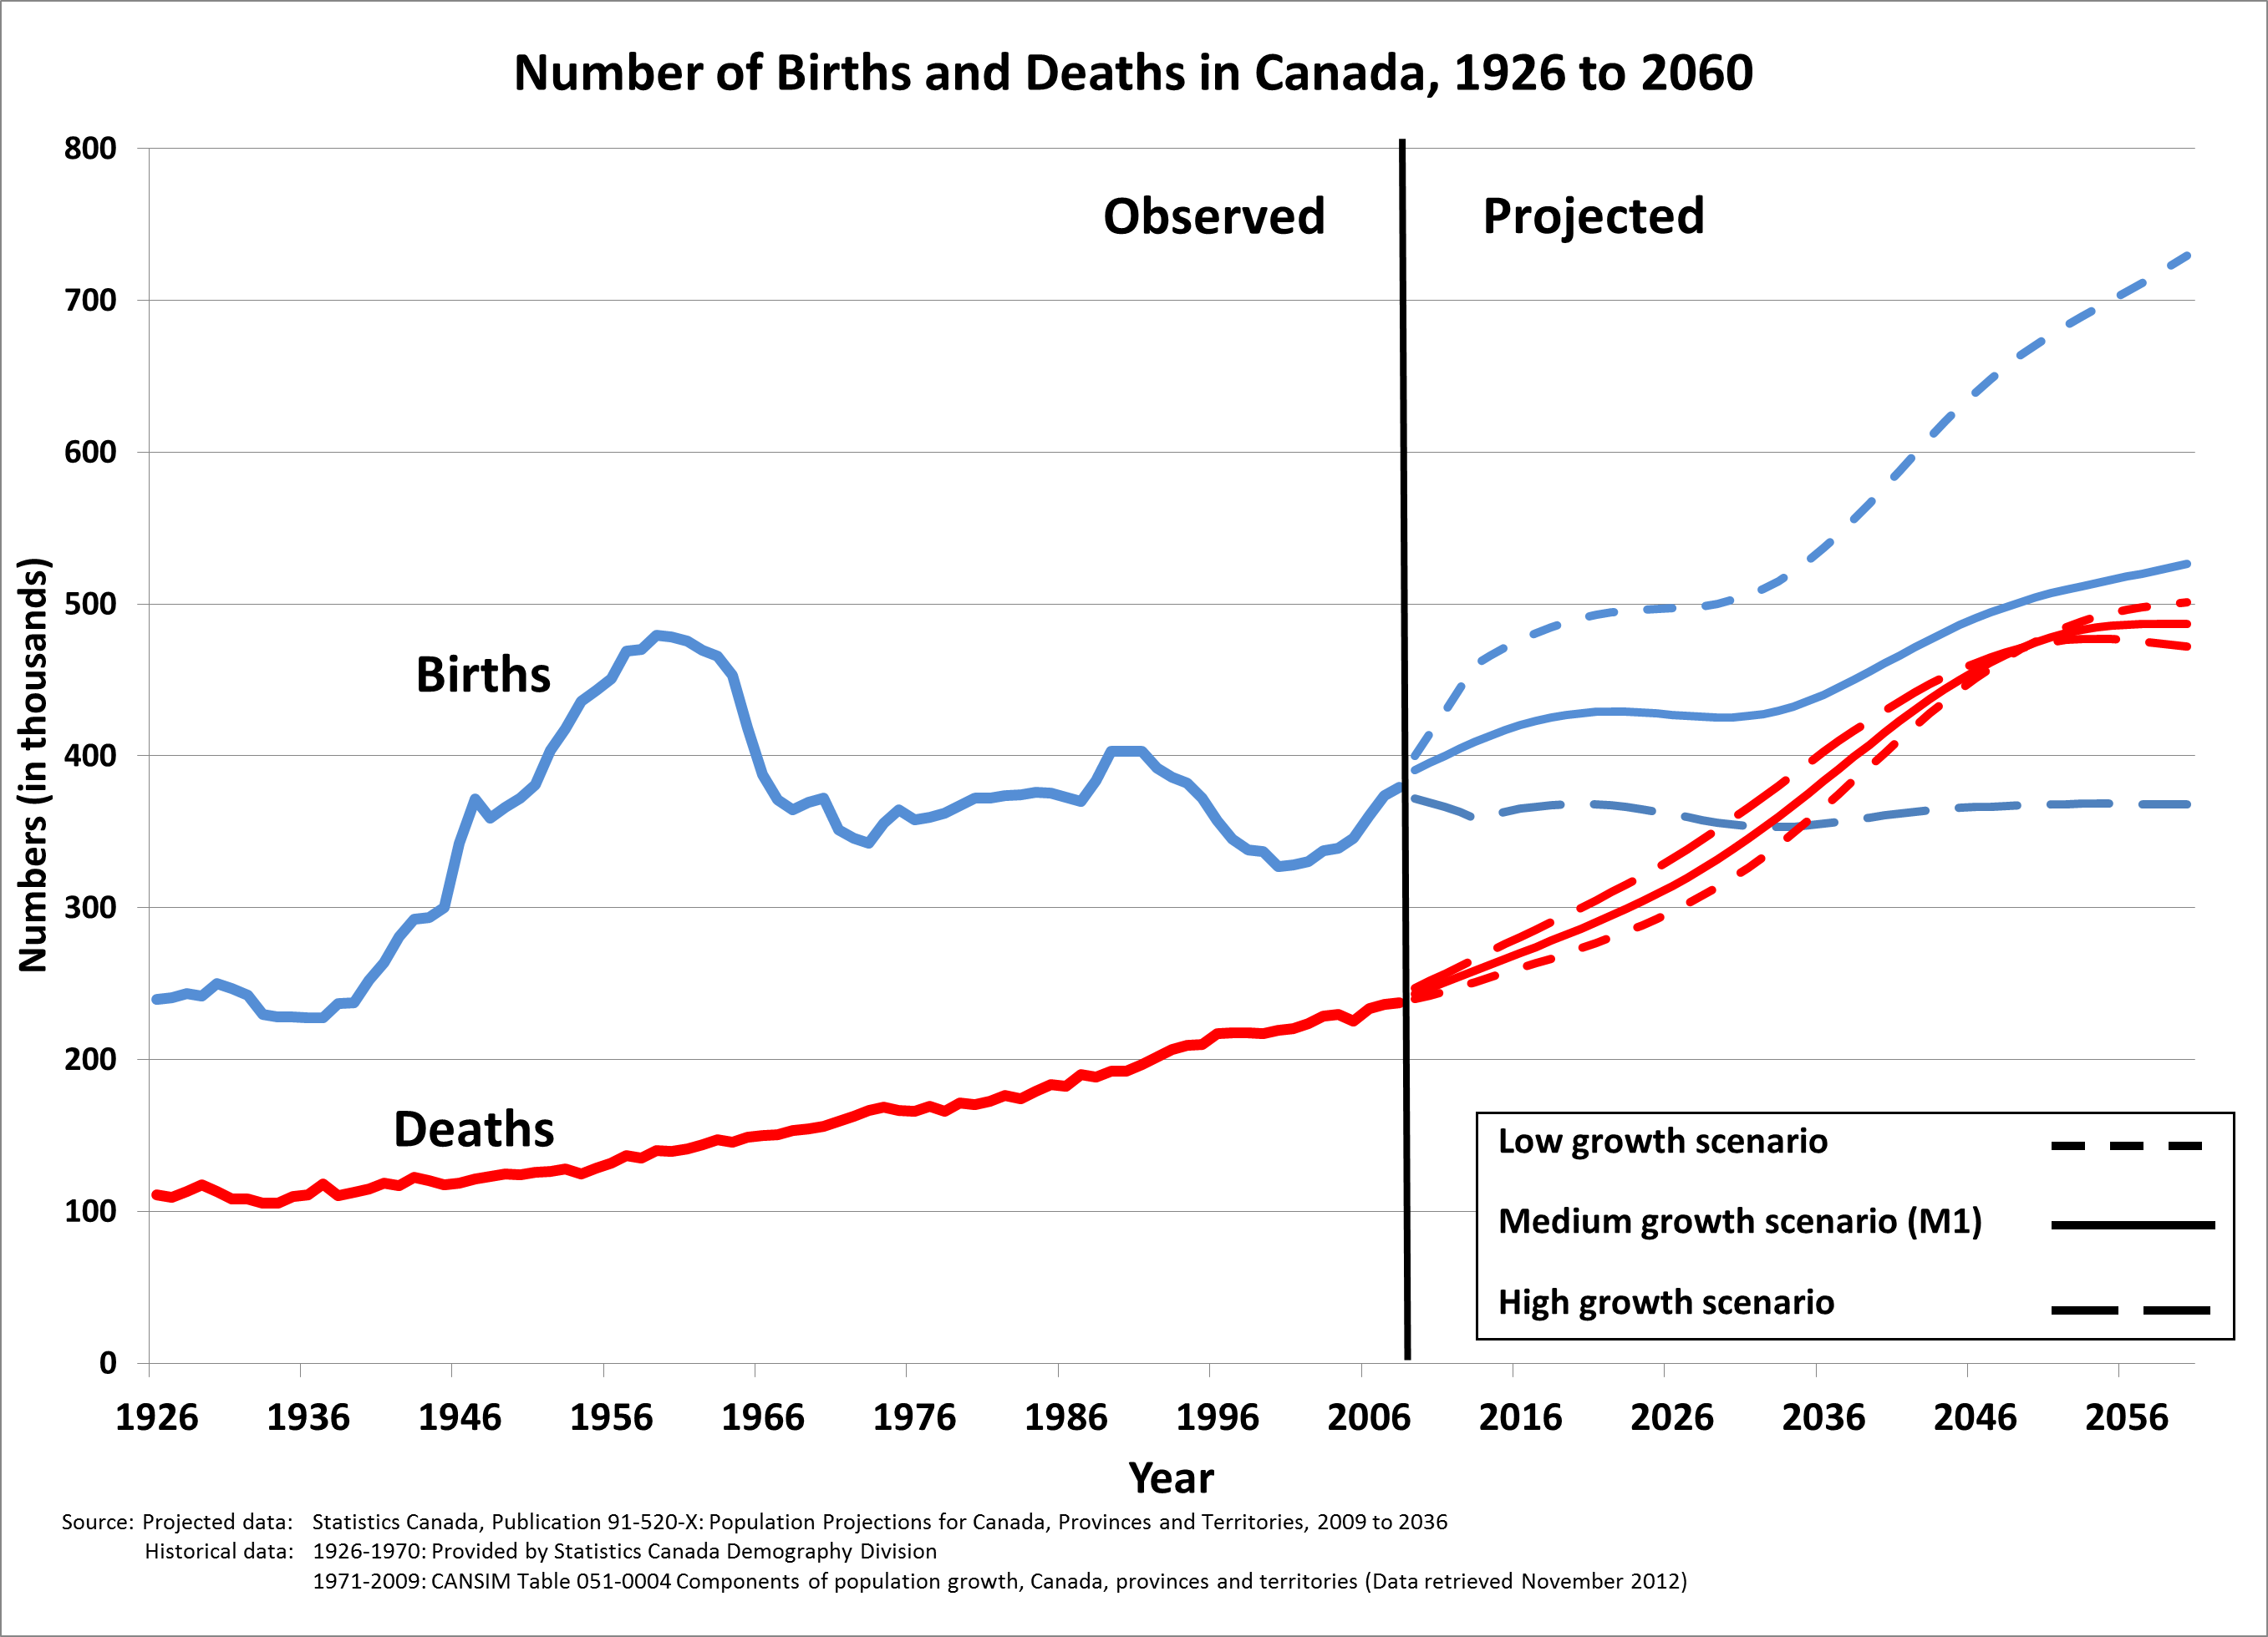

As is true elsewhere, the second reason for Canada’s ageing population is rising Life Expectancy as seen in Table 1. It is interesting that while, in the last century, most of the improvement in life expectancy was driven by improvements at the younger ages, it is now the case that most of the improvement is at ages 60 and over.

**Table 1**

*Table 1 – Life Expectancy in Canada*

|  |  |  |  |  |  |  |
| --- | --- | --- | --- | --- | --- | --- |
| Year | At Birth | | At Age 65 | | At Age 75 | |
|  | Male | Female | Male | Female | Male | Female |
|  | | | | | | |
| 1921 | 58.8 | 60.6 | 13.0 | 13.6 | 7.6 | 8.0 |
| 1941 | 63.0 | 66.3 | 12.8 | 14.1 | 7.5 | 8.2 |
| 1961 | 68.4 | 74.2 | 13.5 | 16.1 | 8.2 | 9.5 |
| 1981 | 71.9 | 79.0 | 14.6 | 18.9 | 9.0 | 11.9 |
| 2001 | 76.9 | 82.0 | 17.0 | 20.5 | 10.3 | 12.9 |
| 2006 | 78.3 | 82.9 | 18.1 | 21.3 | 11.2 | 13.5 |

*Source: Statistics Canada: Life Tables, Canada and the Province*

It would be very easy, in fact, quite natural, to expect that once the baby boom passes away, demographic measures such as the Aged-Dependency Ratio, would return to levels similar to those of today. This is not the case. The baby boom is an important cause of the rapidly ageing population in Canada, but it really only advanced the impact of population ageing. With ever increasing life expectancy (as we assume) the Dependency Ratios of today will never be seen again. We can see evidence of this in the next Chart showing the median age of the Canadian population through to 2051.

**Figure 3 Projected Median Age (Medium Growth Scenario) to 2051**

*Figure 3 – Projected Median Age*

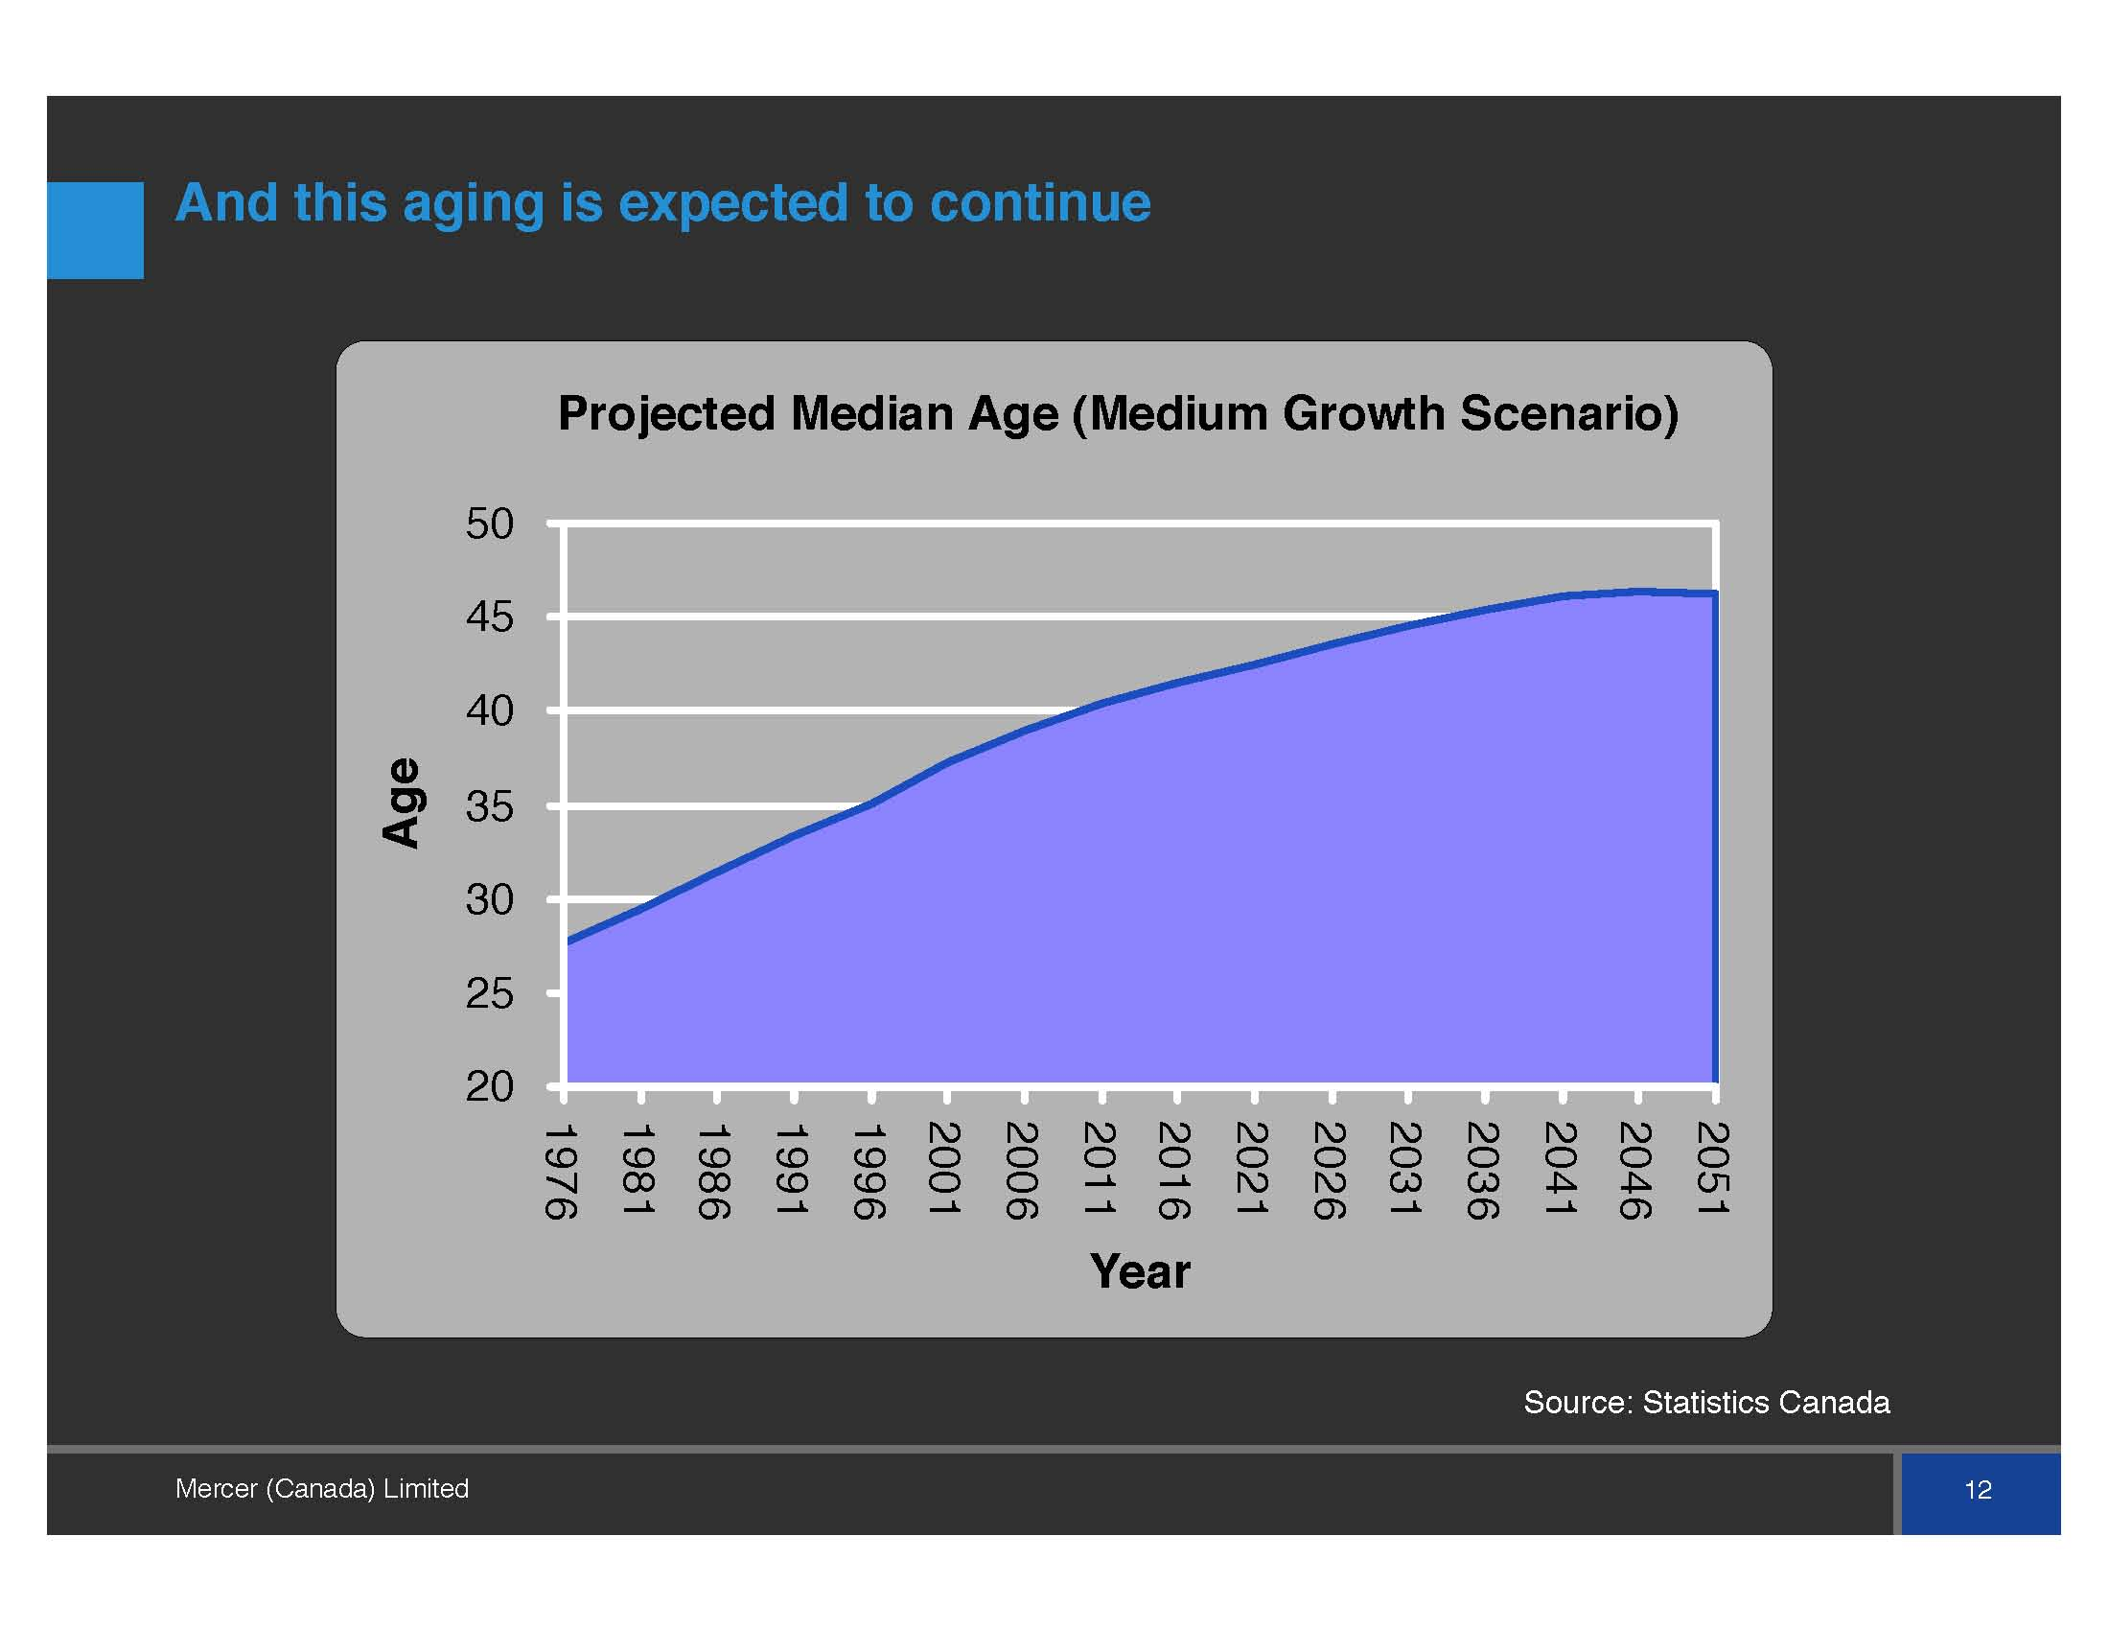

Table 2 shows the distribution of the Canadian Population by age group fro 1956 to 2036. Again, herein we find evidence of the rapidly ageing Canadian population.

**Table 2**

*Table 2 – Distribution of Canadian Population by Age Group, 1956 to 2036*

|  |  |  |  |  |  |
| --- | --- | --- | --- | --- | --- |
| Age | 1956 | 1986 | 1996 | 2016 | 2036 |
|  | | | | | |
| Under 20 | 39.4 | 35.6 | 26.7 | 21.1 | 20.2 |
| 20–64 | 52.9 | 55.8 | 61.1 | 62.4 | 55.0 |
| 65+ | 7.7 | 8.6 | 12.2 | 16.4 | 24.8 |
|  | | | | | |
| 75+ | 2.5 | 3.2 | 5.1 | 7.0 | 12.8 |
| 85+ | 0.4 | 0.7 | 1.2 | 2.1 | 3.8 |

*Source: Statistics Canada Population Projections, 2010*

In turn, Table 3 shows Canada’s Aged Dependency Ratios and the Inverse Ratios (which has previously been referred to as the Aged Support Ratio) from 1956 to 2036. One can see how rapidly these ratios change. The Aged Dependency Ratio is defined as those 65+ to those aged 20-64.

**Table 3**

*Table 3 – Aged Dependency Ratios*

|  |  |  |
| --- | --- | --- |
| Year | ADR | Inverse ADR |
|  | | |
| 1956 | 0.146 | 6.9 |
| 1976 | 0.141 | 7.1 |
| 1996 | 0.200 | 5.0 |
| 2016 | 0.263 | 3.8 |
| 2036 | 0.451 | 2.2 |

Canada has one of the most rapidly ageing populations in the world as seen in Table 4.

**Table 4**

*Table 4 – Aged Dependency Ratios, And Growth Therein, 2050 versus 2010*

|  |  |  |  |
| --- | --- | --- | --- |
| Country | ADR 2010 (%) | ADR 2050 (%) | Increase |
|  | | | |
| Italy | 31.0 | 61.7 | 113.3 |
| Canada | 20.3 | 42.3 | 108.4 |
| France | 25.9 | 43.4 | 99.0 |
| Japan | 35.5 | 69.6 | 96.1 |
| U.S. | 19.5 | 35.4 | 81.5 |
| UK | 25.1 | 39.9 | 59.0 |
| Sweden | 28.0 | 42.3 | 51.1 |

*Source: U.N. data,* [*http://data.un.org/Data.aspx?d=PopDiv&f=variableID%3A44*](http://data.un.org/Data.aspx?d=PopDiv&f=variableID%3A44)

**c) Impact on Social Support Programs**

These rapidly rising Aged Dependency Ratios put at question the sustainability of the Canadian social programs, most notably our Social Security retirement system and our Universal Health Care system.

Canada’s Social Security retirement ystem is made up of three parts:

--The Guaranteed Income Supplement (GIS): a welfare benefit to control poverty among the elderly. It has a 50% claw back rate once the individual’s income reaches the criterion level. GIS benefits are not taxable income. The plan is financed from the general tax base. The GIS is a very important component of the Canadian Social Security system and is much larger than the U.S. Supplemental Security Income.

--Old Age Security (OAS): A basic benefit paid to almost all Canadians except for those who are clearly not in any need. OAS benefits are taxable income. The plan is financed from the general tax base (PAYGO).

--The Canada/Quebec Pension Plans (C/QPP): These plans are self-supporting through employee/employer matched contributions. Contributions and benefits are defined by covered wages (capped at the Average Wage). The replacement ratio of the C/QPP is 25% after 40 years of contributions. The contribution rate for the CPP is 9.9% (4.95% from the employee matched by the employer). Beneficiaries can take their benefits starting as early as age 60 or as late as age 70 with a full actuarial adjustment in benefits. C/QPP benefits are taxable income.

OAS + GIS cost $36.2 B in 2012, and, without change, would cost $108B in 2030. This sounds alarming, but because these benefits are indexed to cost of living, while the tax base grows with the economy, the cost of OAS + GIA which was 2.3% of the GNP in 2012, grows to a peak of 3.1% of GNP in 2030 and then declines slowly to 2.6% in 2050.

In 2012, the government announced that the age of eligibility for OAS/GIS would rise from age 65 to age 67. The shift in age would start in 2023 and be fully implemented by 2029. No similar shift was announced to the C/QPP. While the delay in implementation is advisable, it does mean that there is no impact of this shift for anyone born before 1959. This means that the vast majority of the baby boom will be unaffected. Thus, one must conclude that the purpose of the legislation was for its political impact rather than for its economic impact.

It is also true that similar legislation has been passed in several other OECD countries.

Finally, in many countries, Automatic Balancing Mechanisms (ABMs) have been put in place that automatically shift contributions, or benefits or both in response to changing demographic and economic realities. Those ABMs that automatically raise the age of eligibility to create balance can be viewed as regressive. This is true because wealthy (or higher income) persons live longer than the less wealthy. Thus a shift in the age of eligibility is a larger benefit reduction for a poorer person than for a wealthier person.

Returning to Canada, the C/QPP plans require triennial actuarial valuations (plus a valuation anytime the plan is amended in a manner that has an actuarial impact). The Actuarial Reports indicate that the CPP is sustainable at its current 9.9% contribution rate and that the QPP is sustainable at a contribution rate of 10.8% which will be reached in 2017.

The other major social benefit that will be affected by population ageing is Health Care. Clearly, health care costs are age related. This can be seen in Figure 4.

**Figure 4 Relative Per Capita Costs of Health Care for Males and Females by Age**

*Figure 4 – Relative Per Capita Costs of Health Care for Males and Females by Age*

**Relative cost per capita**

**(arbitrary units)**

*Source: Denton and Spencer, 1995*

Rising health care costs are a serious problem in Canada. Health Care Costs have consistently risen faster than the growth of the economy by 2% to 3% per annum. Thus, there are serious warnings about the impact of the ageing population and our ability to continue to afford our Health Care system.

But, with a further study of the literature we find that health care expenditures are more a function of “time to death” than pure age. This can be seen in Table 5.

**Table 6 Cost Ratio: Died*/Survived Costs of Medical and Social Care by Age**

*Table 6 – Cost Ratio: Died*/Survived Costs of Medical and Social Care by Age*

|  |  |
| --- | --- |
| Age Range | Cost Ratio: Died*/Survived |
|  | |
| 65 | 16.7 |
| 75–76 | 8.4 |
| 85–87 | 3.8 |
| 90–93 | 2.5 |

*\* Last six months of life Source: McGrail et al. (2000)*

What is subtle, but what is important is the combination of these cost factors mixed with improving life expectancy. Health Care costs in Canada are paid out of tax revenues with no prefunding. Thus, the system is purely PAYGO. But, as life expectancy improves, the actual payment of the heightened health care costs continues to be delayed. In a PAYGO system, a dollar of expenditure delayed is a dollar saved. Analysis of this impact was done by Brown and Suresh (2004). In their study, their compared Health Care costs including improving life expectancy against those being presented by most researchers at the time (which did not include the impact of improving life expectancy) (as in Denton Spencer (1995). The results can be found in Table 6.

**Table 6 Health Care Costs Projections**

*Table 7 – Health Care Costs Projection*

|  |  |  |  |  |
| --- | --- | --- | --- | --- |
|  | Denton and Spencer | | Brown and Suresh | |
| Year | Health Care Costs ($B) | 10-Year Growth Rate | Health Care Costs ($B) | 10-Year Growth Rate |
| 2005 | 104.16 | 1.64 | 103.92 | 1.58 |
| 2015 | 123.22 | 1.69 | 122.29 | 1.64 |
| 2025 | 149.23 | 1.93 | 147.38 | 1.88 |
| 2035 | 172.30 | 1.45 | 169.31 | 1.40 |
| 2045 | 180.59 | 0.47 | 176.53 | 0.42 |
| 2055 | 186.06 | 0.30 | 181.01 | 0.25 |
| 2065 | 193.85 | 0.41 | 187.76 | 0.36 |
| 2075 | 199.98 | 0.31 | 192.77 | 0.26 |

*[Note: The 70-year % growth rate is 0.94% per annum in the Denton and Spencer Projection and 0.89% in the Brown Suresh Projection.]*

It is worthy of note that the 70-year average annual growth rate in the Denton and Spencer Projections is 0.94% while in the Brown-Suresh Projections it is 0.89%.

Several studies have shown that the impact of population ageing on Health Care costs in Canada is less than 1% per annum. Thus, if health care costs 10% of GNP today, it would cost no more than 11% in ten years due purely to population ageing. There are other factors causing the extra cost increases in Canadian Health care such as over-servicing and rising prescription costs that must be attended to vigourously. Many providers of health car services hide behind the ageing population in the hope that their segment of the supply chain will not come under scrutiny (“it is beyond our control; it is all because of population ageing.”).

**d) Raising the “Retirement Age”: Good Public Policy?**

It was the position of the Task Force (reinforced by data) that the retirement age would rise without government intervention and that, if economic equilibrium could be maintained, then free market forces should “decide” one’s retirement age, not the government.

Equilibrium is achieved if the supply of goods and services in total matches the demand for goods and services. Supply comes from the active labour force. Demand comes from society at large whether active or not.

Using this basic definition, Brown (1999) introduced a model that shifted the age of retirement to achieve a constant ratio of supply units (units of labour) to the demand units. Assuming a constant ratio implies that future generations are not seeking to increase their standard of living, only to have it remain constant in real terms. Brown’s model moved the retirement age so that the ratio of inactive demand units (the young, the unemployed and the aged) remained a constant ratio of the labour force. By shifting the retirement age, an aged person previously in the numerator of the ratio moved to the active labour force denominator. In effect, you get a double pay off with this move. So long as this ratio is “satisified” workers can retire at the earliest age they desire.

This led to the following retirement ages (Brown, Damm and Sharara (2001)).

**Figure 5 Median Retirement Age in Canada (1996 to 2047)**

*Figure 5 – Median Retirement Age in Canada (1996 to 2047)*

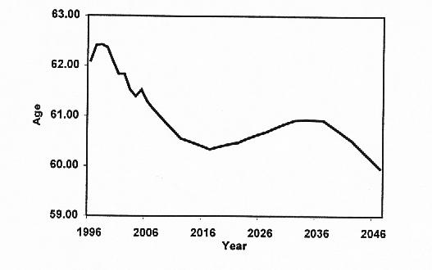

*Source: Brown, Damm, Sharara, (2001, p8)*

The authors back-tested their model against data from the previous fifteen years with a very high correlation of actual to model retirement ages. The authors concluded that what the model indicated was a rather mild rise in the median retirement age that would then satisfy the supply/demand equilibrium. Further, the authors noted that the model assumed productivity increases of 0.9% per annum (which was a historical average). Were productivity growth to rise to 1.29% per annum the retirement age would never have to rise (but would only provide a constant standard of living). Finally, the authors concluded that a rise in the retirement age was inevitable regardless of public policy initiatives.

In fact, in Canada, the average age of Labour Force exit (retirement) started to rise around 2001. Note that the year one exits the labour force is not necessarily connected to any change in the age at which one’s pension starts. And, this rise in actual retirement age started more than a decade prior to the announcement that the OAS/GIS age of entitlement would rise (and 22 years prior to when that would take effect).

This can be seen clearly in Figure 6.

**Figure 6 Average Exit Age from the Labour Force**

*Figure 6 – Projected Average Exit Age from the Labour Force Based on the Assumptions of the 25th CPP Report*

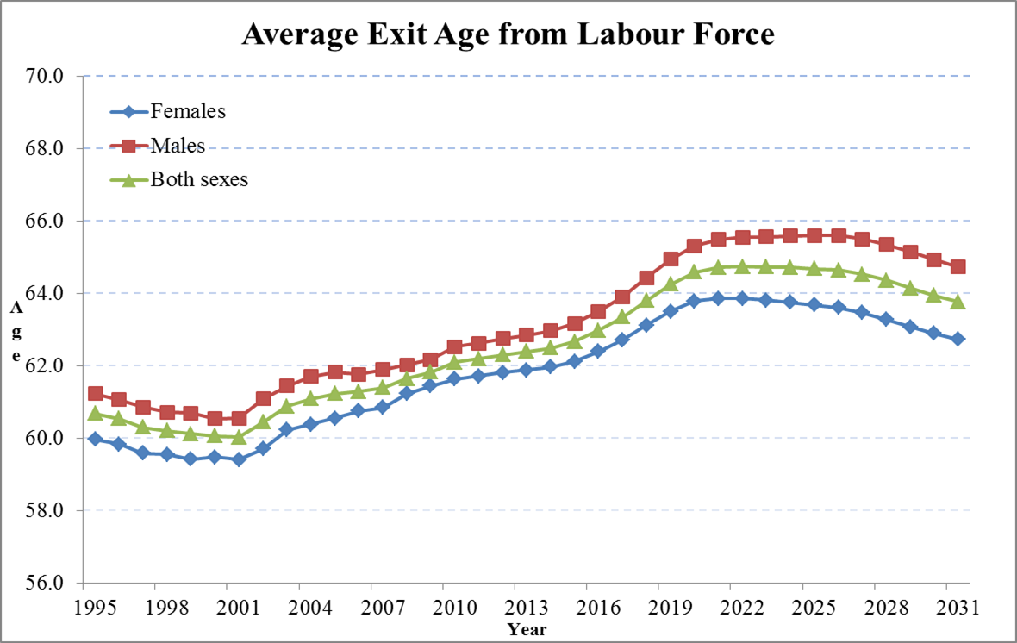

*Source: Office of the Chief Actuary, Canada*

Further evidence of this shift is provided in Table 7.

**Table 7 CPP: Proportion of Beneficiaries Working**

**Female**

**Age 2001 2005 2009**

**60-64 14.4% 19.7% 26.4%**

**65-69 10.1 12.5 16.8**

**70-74 5.0 5.8 7.4**

**75+ 2.0 2.1 2.5**

**Overall 6.6 8.1 10.9**

**Male**

**60-64 24.1% 31.9% 37.2%**

**65-69 17.6 21.1 26.1**

**70-74 9.5 10.9 13.6**

**75+ 4.4 4.6 5.5**

**Overall 11.8 14.2 17.6**

Similar trends are apparent in many other OECD countries.

Even if Canadian retirement age rises, workers will still spend more years in retirement than was true before as illustrated in Table 8.

***Table 8 – Changes in the Active Life to Retirement Ratio for Québec***

|  |  |  |  |
| --- | --- | --- | --- |
| Year | Active Life (Years) | Retirement (Years) | Ratio A/R |
| Males | | | |
| 1980 | 42.8 | 16.7 | 2.6 |
| 1990 | 41.7 | 19.4 | 2.2 |
| 2005 | 41.9 | 21.7 | 1.9 |
| Females |  |  |  |
| 1980 | 42.5 | 21.9 | 1.9 |
| 1990 | 41.2 | 24.3 | 1.7 |
| 2005 | 40.7 | 26.0 | 1.6 |

*Source: Actuarial Report of the Québec Pension Plan as at 31 December 2006.*

1. **Impact on Defined Benefit Pension Plans**

Defined Benefit Pension (DB) plan coverage has declined in Canada as it has in many parts of the world, but not to the same extent. DB plans are still common in the Public Service (82% of Public Sector workers have DB plans) and large unionized employers. Only one-third of the private sector has any pension plan at all and less than 20% have a traditional DB plan. Reasons for the decline in private sector coverage includes:

--lower cost and more predictable costs

--some workers want to work longer either because they like their work or because they need to save for a longer period

--workers may prefer phased retirement

--employers have concerns about potential upcoming labour shortages

DB plans often encourage retirement at an early age by paying benefits with no actuarial discount versus those taken at the “normal retirement age”. This is expensive, but popular. It does provide an incentive to retire early even though workers misinterpret the value of the non-discounted benefits (i.e., early versus late).

Some plans (especially the public sector plans) are shifting to quasi Target Benefit plans (e.g., indexation of benefits only occurs if the plan funding is healthy) and matching employee/employer contributions.

Many private sector plans have shifted to Defined Contribution plans (DC). These plans offer no retirement age incentive (either early or late). They offer more flexibility in portability of benefits. The shift from DB to DC plans is expected to increase the retirement age further since the benefits of most DC plans are not as large as those of most existing DB plans.

It is worth noting that the CPP offers no incentive to retire early or late since benefits have a full actuarial adjustment for both early and late takers.

But the over-arching question remains: “What role should the government play in trying to influence when workers retire?”

The report noted that other government plans will feel a direct impact if the eligibility age and the retirement age rise. Such plans include:

--Provincial Welfare Programs

--Workers’ Compensation

--Employment Insurance

--Disability Plans (both public and private)

--Group Insurance Plans

1. **Mitigating Variables**
2. Fertility: Fertility rates in Canada are rising very slowly but no-one expects them to rise to the replacement level of 2.1 (today they are close to 1.6). The literature indicates that it is very difficult to increase fertility rates through financial incentives.
3. Immigration: Canada has always had very high net immigration rates (0.5 to 0.6%). Obviously, immigration can be used to replace non births. But immigration is only truly valuable if:

--the net level is sustained or increased,

--the average age of immigration declines,

--a higher percentage of immigrants are labour force prepared (today, 23% of immigrants are “Family Completion” status).

iii) Labour Force Participation: The report assumed that there would be an increased demand for workers as the baby boom continued to retire. Further, it was assumed that work is not as physically demanding today as for past cohorts. There is a need to make sure that jobs are available and that the labour supply matches the needs of those jobs. However, the report concluded that there is not much room for large increases here since participation rates for both males and females are already quite high.

iv) Productivity: Labour shortages and higher wages will make capital investment and innovation a wise decision. The literature indicates that raising labour productivity can go a long way to solving the negative impacts of an “Ageing Population”. Thus, this is an important variable to target.

1. **Conclusion**

An ageing population could cause a lower standard of living. This would be because of the higher Old-Age Dependency Ratio, higher taxes needed to maintain public programs and the lower productivity of older workers.

Others argue that an ageing population could lead to a higher standard of living. This would be because of the lower overall population growth rate, a higher savings rate and lower taxes as retirees cash in their tax-deferred retirement savings plans and pay the income tax thereon.

The report concludes with a short narrative on what is often referred to as: “The Lump of Labour Fallacy”. Many social commentators worry that keeping older workers active in the labour force to a later age could increase youth unemployment and rob the young of jobs. The literature says that this is a wrong conclusion. The data tell us that more workers mean more GNP and more, not fewer, jobs. Thus the phrase: “Lump of Labour Fallacy’.

**CIA Task Force Report Bibliography**

Barer, M. L., R.B. Evans, and C. Hertzman. 1995. Avalanche or Glacier? Health Care and the Demographic Rhetoric. *Canadian Journal on Aging.* Vol. 14, No. 2: 193-224.

Beach, C. M. 2008. *Canada’s Aging Workforce: Participation, Productivity, and Living Standards.* Bank of Canada.

Brown, R. L. 1999. Economic Security for an Aging Canadian Population. SOA Monograph MRS99-2. Schaumburg: Society of Actuaries.

Brown, R. L. and C. Bilodeau. 1999. “The Canadian Wealth Transfer Index”. *Proceedings, Canadian Institute of Actuaries,* Vol. XXVIII, No. 2 (1996-97).

Brown, R. L., R. Damm, and I. Sharara. 2001. “A Macro-Economic Indicator of Age at Retirement”. *North American Actuarial Journal*. Vol. 5, No. 2.

Brown, R. L. and U. Suresh. 2004. “Further Analysis of Future Canadian Health Care Costs”. *North American Actuarial Journal.*

Canadian Institute of Actuaries. 1996. Health Care Financing Task Force on Health Care Financing.

Choi, James, David Laibson, and Brigitte Madrian. 2011. “$100 Bills on the Sidewalk: Suboptimal Investment in 401(k) Plans.” *Review of Economics and Statistics* 93(3): 748-763.

Denton, F. T., and B. G. Spencer. 1995. “Demographic Change and the Cost of Publicly Funded Health Care”. *Canadian Journal on Aging* 14(2): 174-192.

Denton, F. T., C. H. Feaver, and B. G. Spencer. 2005. Population Aging and the Maintenance of Social Support Systems. Quantitative Studies in Economics and Population (QSEP) Research Reports. #320. McMaster University.

Evans, R. G., K. M. McGrail, S. G. Morgan, M. L. Barer, and C. Hertzman. 2001. “Apocalypse No: Population Aging and the Future of the Health Care System”. *Canadian Journal on Aging* 20(1): 160-91.

European Commission. 2012. White Paper on adequate, safe and sustainable pensions.

Federal Government of Canada. 2012. Jobs, Growth and Long-term Prosperity – Economic Action Plan 2012.

Hering, M., and T. R. Klassen. 2010. Is 70 the New 65? Raising the Eligibility Age in the Canada Pension Plan. Mowat Centre for Policy Innovation.

Hicks, P. 2012. *Later Retirement: the Win-Win Solution.* Commentary No. 345. Toronto: C. D. Howe Institute.

Hogan, S., and S. Hogan. 2002. How Will the Aging of the Population Affect Health Care Needs and Costs in the Foreseeable Future? Discussion Paper no. 25 in “The Future of Health Care in Canada”. *Report of the Commission on the Future of Health Care in Canada* (The Romanow Report).

Huberman, G., S. S. Iyengar, and W. Jiang. 2007. “Defined Contribution Pension Plans: Determinants of Participation and Contribution Rates.” *Journal of Financial Services Research*, 31(1): 1-32.

Ignaczak, L., and M. Voi. 2009. A Nonparametric Analysis of Canadian Employment Patterns.

ILO. 2008. Age discrimination and older workers: Theory and legislation in comparative context. *Conditions of Work and Employment Series No. 20*.

IMF. 2011. The Challenge of Public Pension Reform in Advanced and Emerging Economies.

*Investment & Pensions Europe.* <http://www.ipe.com/news/dutch-parties-to-increase-retirement-age-sooner-than-expected_47715.php> (registration required).

Kamhi, N., and D. Leung. 2005. *Recent Developments in Self-Employment in Canada.* Bank of Canada.

Marzouk, M. S. 1991. “Aging, Age-Specific Health Care Costs and the Future Health Care Burden in Canada”. Canadian Public Policy, University of Toronto.

McGrail, K., B. Green, M. L. Barer, R. G. Evans, C. Hertzman, and C. Normand. 2000. “Age, Costs of Acute and Long-Term Care and Proximity to Death: Evidence for 1987-88 and 1994-95 in British Columbia.” *Age and Ageing 2000*. 29(3): 249-53.

Mosisa, A., and S. Hipple. 2006. “Trends in Labor Force Participation in the United States”. *Monthly Labor Review*.

OECD. 2011. A method for calculating the average effective age of retirement. Paris: OECD.

OECD. 2011.Pensions at a Glance 2011: Retirement-Income Systems in OECD and G20 Countries.

OECD. 2011. “Paying for the Past, Providing For The Future: Intergenerational Solidarity”. Ministerial Meeting on OECD Social Policy: Building a Fairer Future: The Role of Social Policy.

OECD. 2012. Pensions Outlook 2012.

OECD. 2010. Off to a Good Start? Jobs for Youth.

OECD. 2012. OECD Economic Surveys: Denmark 2012, OECD, Box 1.4.

OECD. 2011. Statistics on average effective age and official age of retirement in OECD countries.

Office of the Chief Actuary, Office of the Superintendent of Financial Institute, Canada. 2010. The 25th Actuarial Report on the Canada Pension Plan as at 31 December 2009.

———. 2002. The 5th Actuarial Report on the Old Age Security as at 31 December 2000.

———. 2011. The 9th Actuarial Report on the Old Age Security Program as at 31 December 2009.

———. 2011. The 10th Actuarial Report supplementing the Actuarial Report on the Old Age Security Program as at 31 December 2009.

———. 2012. The 11th Actuarial Report supplementing the Actuarial Report on the Old Age Security Program as at 31 December 2009.

Régie des rentes du Québec. 2009. Working Paper - Toward a Stronger and Fairer Québec Pension Plan.

———. 2010. Actuarial Report of the Québec Pension Plan as at 31 December 2009.

———. 2010. La transition travail-retraite – Données de 1991 à 2007.

———. 2007. Actuarial Report of the Québec Pension Plan as at 31 December 2006.

Robson, W. B. P. 2001. “Will the Baby Boomers Bust the Health Budget? Demographic Change and Health Care Financing Reform”. *C. D. Howe Commentary* no. 148, February.

Scarth, W. 2007. *Some Macroeconomic Effects of Population Aging on Productivity Growth and Living Standards.* McMaster University.

Sepehri, A., and R. Chernomas. 2004. “Is the Canadian health care system fiscally sustainable?” *International Journal of Health Services,* Vol. 34, No. 2: 229-243.

Statistics Canada. 1999. Catalogue no. 75-001-XPE.

———. 2001. *Education Quarterly Review*. Volume 7, no.3.

———. 2003. The Canadian Labour Market at a Glance.

———. 2008. Canadian Demographics at a Glance.Catalogue no. 91-003-X, Minister of Industry.

———. 2010. Population Projections for Canada, Provinces and Territories, 2009-2036.Catalogue No. 91-520-X. Minister of Industry.

———. 2011. Report on the Demographic Situation in Canada.

———. 2012. The evolution of wealth over the life cycle.

———. 2012. Pension plans in Canada, as of January 1, 2011. *The Daily,* May 25, 2012.