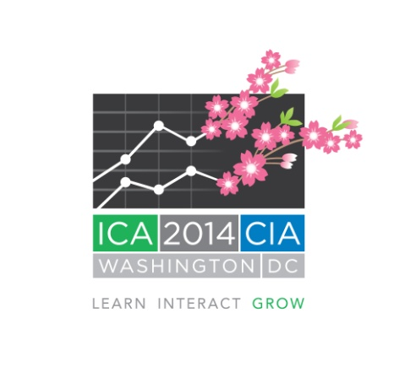

**Registration is Open for ICA 2014**

The International Actuarial Association and the actuarial profession in the United States invite you to register for ICA 2014, scheduled for 30 March to 4 April 2014 in Washington, D.C.

In addition to several plenary sessions intended for all delegates, ICA 2014 will provide an abundance of content in seven parallel tracks to appeal to actuaries of all disciplines and interests, and to provide a significant volume and variety of continuing professional development opportunities. Tracks include:

* Consulting
* Enterprise Risk Management/Financial Risk
* Health
* Life
* Pensions, Benefits and Social Security
* Professionalism
* Property-Casualty/General Insurance

Three different registration packages are available, and attendees can select a package that meets their educational interests and needs. The packages include:

* Package A - Full Week, 30 March to 4 April, includes all sessions
* Package B - Sunday through Wednesday, 30 March to 2 April, features Life and Pensions, Benefits and Social Security sessions.
* Package C - Wednesday through Friday, 2 April to 4 April, features Health and Property-Casualty/General Insurance sessions.

Sessions on Consulting, Enterprise Risk Management/Financial Risk, and Professionalism will be offered throughout the entire week of the conference.

In total, delegates attending the full week of ICA 2014 will have access to up to 27 actual hours of continuing professional development; delegates attending the first half of the week have access to up to 18 hours and those attending the second half 15 hours.

Register online today! Early registration fees will increase after August 31, 2013.

The theme of ICA 2014 is Learn, Interact, Grow. All aspects of the conference are being designed to give delegates and their guests a variety of opportunities to do exactly that. Attendees will:

* Learn about the latest ideas in actuarial practice,
* Interact with actuaries and other risk professionals through the educational and social events, and
* Grow from the stimulating educational sessions and from engagement with professionals from countries and cultures around the world.

The dates of ICA 2014 were chosen to coincide with one of the most beautiful times of the year in Washington, D.C. – Spring! This is when the 3,000+ cherry blossom trees that line the Potomac River are in full bloom. Join other actuaries from around the world to witness their spectacular beauty.

Please visit the ICA 2014 website at [www.ica2014.org](http://www.ica2014.org) for more information and to register. While visiting the website, sign up for the ICA 2014 email newsletter to receive alerts when significant new information is available.

If you have questions about ICA 2014, please contact [info@ica2014.org](mailto:info@ica2014.org).