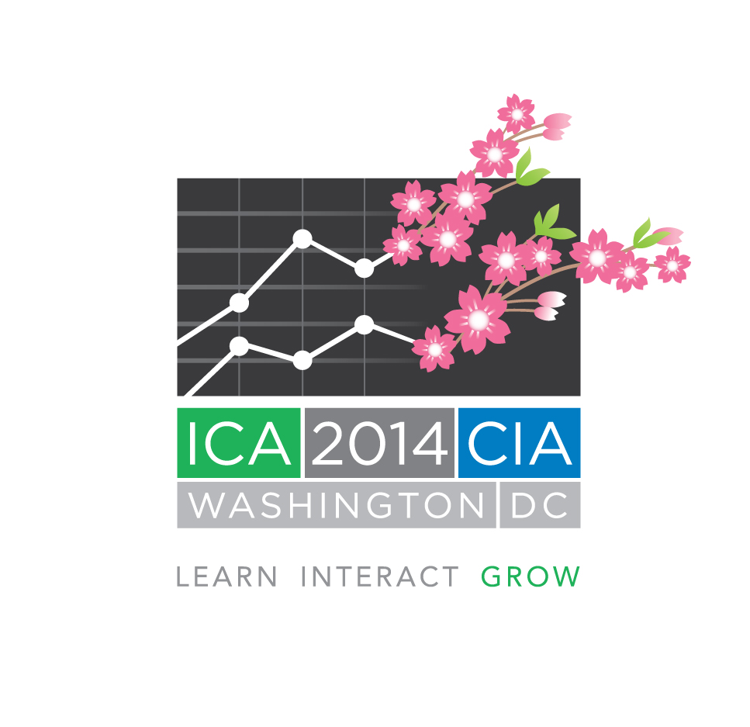
ICA 2014 Buzz Kit
(Updated 4 April 2013)

Actuarial organizations around the world are invited to help promote ICA 2014 by creating a “buzz” around the event through social media.

Please feel free to use the sample announcements below to post on Twitter, Facebook, LinkedIn, or any other social networks. Please use our Twitter hash-tag - #ICA2014.

You are also welcome to follow ICA 2014 on Twitter and re-tweet our posts to your followers.

Sample Social Media Posts:

Register for ICA: ICA 2014 Registration is Now Open! Register Online Today and Make Plans for Washington, D.C. http://bit.ly/13VglL8

ICA Program: Check Out the Topics that Will be Covered During ICA 2014! http://bit.ly/ZcWIFI

Workshops: Learn More About the Limited Attendance Workshops and Off-Site Educational Tours Available at ICA 2014. http://bit.ly/Z4RHQn

ICA Hotel Info: Learn More About the Official ICA 2014 Hotel, the Washington Marriott Wardman Park. http://bit.ly/16tkeCw

ICA Hotel Info: Don’t Forget to Reserve Your ICA 2014 Hotel Room at the Washington Marriott Wardman Park Hotel! http://bit.ly/16tkeCw

Flights to DC: Visit the ICA 2014 Website to Learn More About Planning Your Travel Arrangements to Washington, D.C. http://bit.ly/XslxTN

Visa Info: Traveling Internationally to Washington, D.C. for ICA 2014? Then Visit the ICA 2014 Website for Information on Visas. http://bit.ly/XsnpMj

Travel Tips: Traveling to Washington, D.C. for the First Time? Then Visit the ICA 2014 Website for Some Useful Travel Tips. http://bit.ly/10Ck1tJ

DC area Transit: Check Out the Great Public Transportation Options Available in Washington, D.C. for ICA 2014. http://bit.ly/10zZLdy

Tourist Info: Check Out What Washington, D.C.-based Actuaries Recommend for Fellow Actuaries Visiting Washington, D.C. for ICA 2014. http://bit.ly/Z6K8Zx

